Bahria University,
Karachi Campus

Course: SEN (221)
SOFTWARE DESIGN & ARCHITECTURE
Term: Spring 2021, Class: BSE- 4(B)

PROJECT REPORT

Project Title:
Knight’s tour problem

Submitted To:
Engr. Majid Kaleem/Engr. Rehan Baig

Signed Remarks: Score:

Knight’s Tour Problem



By:
Nausheen Kaleem
Areej Fatima
Hasnain Khalid
Zoya Hasan

29th June, 2021.

TABLE OF CONTENTS

INTRODUCTION: ……………………………………………………………………………04
PROBLEM: …………………………………………………………………………………...04
EXPLANATION & DESCRIPTION: ……………………………………………………….....06
SOFWATRE DESIGN PATTERNS: …………………………………………………………..09
C SHARP CODE: ………………………………………………………...…………………...09
INTERFACES: ………………………………………………………………………………. 49
CONCLUSION: ………………………………………………………………………………56
REFERNCES: ………………………………………………………………………………...56

INTRODUCTION
Chess is a two player game played on a square board. Generally chess is played on a board with 8 rows and 8 columns; however, we will deal with the more general case where the board contains m rows and m columns. For the purposes of this paper we will assume the orientation of a board is fixed so that we can label all the squares. Let column 1 denote the leftmost column and row 1 denote the top row. We denote each square by the ordered pair (i, j), where i is the row number and j is the column number. Each player receives six different types of pieces, each of which has a different set of rules governing its possible moves. In this paper we are specifically concerned with the knight. A knight’s move follows an L-shape; it can move either one row over and two columns over, or two rows over and one column over (in either direction). We say that two squares are adjacent if a knight can move from one square to the other (we also call the two squares neighbors).
A classical problem on the chess board is the Knight's Tour. In this, a knight is moved such that it visits every square at least once. This problem is most commonly discussed as a mathematical problem and appears in Artificial Intelligence as the most popular problem. In addition, this issue is only applicable to the 8x8 regular chess board. At least one knight's tour on such a board exists. And this project is aimed at finding a tour of all the possible tours.


PARADIGMS
The earliest known reference to the knight's tour problem dates back to the 9th century AD. In Rudraṭa's Kavyalankar, a Sanskrit work on Poetics, the pattern of a knight's tour on a half-board has been presented as an elaborate poetic figure (citra-alaṅkāra) called the 'arrangement in the steps of a horse'. The same verse in four lines of eight syllables each can be read from left to right or by following the path of the knight on tour. Since the Indic writing systems used for Sanskrit are syllabic, each syllable can be thought of as representing a square on a chessboard.
It is believed that Desika composed all 1008 verses (including the special Chaturanga Turanga Padabandham) in a single night as a challenge.
A tour reported in the fifth book of Bhagavantabaskaraby by Bhat Nilakantha, a cyclopedic work in Sanskrit on ritual, law and politics, written either about 1600 or about 1700 describes three knight's tours. The tours are not only reentrant but also symmetrical, and the verses are based on the same tour, starting from different squares. The work by Bhat Nilakantha is an extraordinary achievement being a fully symmetric closed tour, predating the work of Euler (1759) by at least 60 years.One of the first mathematicians to investigate the knight's tour was Leonhard Euler. The first procedure for completing the knight's tour was Warnsdorff's rule, first described in 1823 by H. C. von Warnsdorff.
In the 20th century, the Oulipo group of writers used it, among many others. The most notable example is the 8 × 8 knight's tour which sets the order of the chapters in Georges Perec's novel Life a User's Manual.
A knight’s path is a sequence of squares such that all pairs of consecutive squares are adjacent and no square appears in the sequence more than once. We can illustrate a knight’s path by labeling each square by the order of its appearance in the sequence, with dashes denoting squares that do not appear in the sequence. At any point in a knight’s path we call a square visited if it has already appeared in the sequence and unvisited if it has not appeared. In our diagrams this means that visited squares contain a number less than or equal to the number in the current square, while unvisited squares contain either a number higher than the number in the current square or a dash. We call the number of unvisited squares that are adjacent to a given square the degree of the square.

A knight’s tour is a knight’s path that includes every square of the board. Here is an example of knight’s tour on an 8x8 board:

1 | 16 | 27 | 22 | 3 | 18 | 47 | 56
26 | 23 | 2 | 17 | 46 | 57 | 4 | 19
15 | 28 | 25 | 62 | 21 | 48 | 55 | 58
24 | 35 | 30 | 45 | 60 | 63 | 20 | 5
29 | 14 | 61 | 34 | 49 | 44 | 59 | 54
36 | 31 | 38 | 41 | 64 | 53 | 6 | 9
13 | 40 | 33 | 50 | 11 | 43 | 52 | 32
32 | 37 | 12 | 39 | 42 | 51 | 10 | 7

EXPLANATION & DESCRIPTION
This project consists of following features:
INITIAL POSITION:
To begin the search for the tour, the program asks for the initial square. Once the user provides the starting square information, the program progressively searches for all available squares that are likely to complete the tour.
NON-INTELLIGENT METHOD:
The "Non-Intelligent" strategy makes the knight pick every open position on the chessboard randomly. It allows the Knight to move up to 50 squares from our code, and sometimes only up to 10 squares. This strategy was a fast way to determine the positions open, since it did not measure which of the possible movements was the better one. For this reason, the results of this technique will cause discrepancy.
HEURISTICS METHOD:
The method of "Heuristics" allows the knight to select the best square possible to move to. The outer squares on the chessboard are more difficult than the squares in the centre of the board, but much more difficult are the corner squares. The knight chooses the most difficult squares first in this process. This will allow the knight first to handle the rough squares, then manage the easiest ones to reach last.
The idea is basically to build a chess which contains n rows and m columns. Let column 1 denote the leftmost column and row 1 denote the top row. We set each square by the ordered pair (i, j), where i is the row number and j is the column number. The programming language used will be C sharp using windows form application.
Knight's tour is a problem in which we are provided with a 8x8 chessboard and a knight.
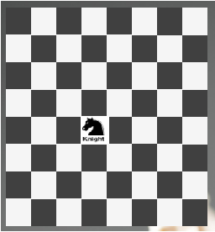
When a new user will comes up on the game which is not familiar with chess, the knight moves two squares horizontally and one square vertically, or two squares vertically and one square horizontally.
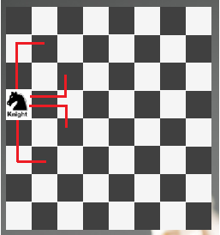
Since, if a knight is at (1, 4), it can move to the (2, 2), (3, 3), (5, 3), (6, 2), (5, 2), cells.
Therefore, one complete movement of a knight looks like the letter "L", which is 2 cells long.
According to the basics of game, we have to make the knight cover all the cells of the board and it can move to a cell only once.
This game will be consisting three phases. In initial phase user will let the system knows about the credentials of Initial Square. Once the credentials are on air, system will progressively search for all available squares.
The next phase is based on Non-intelligent method, it will help the knight to pick every position on the chessboard randomly. This strategy is the fastest way to determine the open positions.
In the last phase Heuristic method will let the knight to select the best square to move to. In this process knight will choose the most difficult square, the strategy behind this is that knight will be able to handle the rough squares on priority basis.
Likewise to the N-Queens problem, we start by moving the knight and if the knight reaches to a cell from where there is no further cell available to move and we have not reached to the solution yet (not all cells are covered), then we backtrack and change our decision and choose a different path.
So from a cell, we choose a move of the knight from all the moves available, and then recursively check if this will lead us to the solution or not. If not, then we choose a different path and so on.

SOFTWARE DESIGN PATTERNS
As we worked on Chess board game in which a knight moves using two Algorithm to change it position at runtime. Keeping this in mind, the most suitable design pattern we used is Strategy pattern.
Strategy Pattern : The Strategy pattern is known as a behavioural pattern – it’s used to manage algorithms, relationships and responsibilities between objects. The main benefit of strategy pattern is to choose the algorithm/behaviour at runtime. This helps our knight to act accordingly.

For illustration, in a common chess game scenario, There are different characters like King, Queen, Bishop and all of them have different moves. There could be many possible solutions to this design, lets explore one by one :

1) The first way would be to define movement in each and every class, every character will have its own move() implementation. In this way there is no code reusability and we can not change the implementation at run time.

2) Make a separate MovementController Class and put an if else for each type of movement of an object.

C SHARP CODE

Chess Board:

Form1.cs:

using System;
using System.Collections.Generic;
using System.ComponentModel;
using System.Data;
using System.Drawing;
using System.Linq;
using System.Text;
using System.Threading.Tasks;
using System.Windows.Forms;
using System.IO;

namespace projecc
{
delegate void Output(int row, int col, int position);
delegate void InsertZero();
delegate void Print(string file);
delegate void Reader(string file);
public partial class Form1 : Form
{
int time = 1;
int count = 1;
int avg = 0;
string file = "";
int hurMove = 0;
int[] touch = new int[10];
const int SIZE = 8;
int[,] chessBoard = new int[SIZE, SIZE];
int[,] gameboard = new int[SIZE, SIZE];
int[,] movepoints = new int[SIZE, SIZE];
int curX = 0;
int curY = 0;

//------------ functions to check the availability of move using heuristics method ----------
//function to check North-North-West

Check North North west Method:

public int checkNNW(int x, int y)
{
if (((x - 1) >= 0 && (x - 1) < 8) && ((y - 2) >= 0 && (y - 2) < 8))
{
if (gameboard[x - 1, y - 2] == 0)
{
return movepoints[x - 1, y - 2];
}
else
{
return 30;
}
}

return 30;
}

Check West North west Method:

//function to check West-North-West
public int checkWNW(int x, int y)
{
if (((y - 1) >= 0 && (y - 1) < 8) && ((x - 2) >= 0 && (y - 2) < 8))
{
if (gameboard[x - 2, y - 1] == 0)
{
return movepoints[x - 2, y - 1];
}
else
{
return 30;
}
}

return 30;
}

Check West South West Method:

//function to check West-South-West
public int checkWSW(int x, int y)
{
if (((y + 1) >= 0 && (y + 1) <= 7) && ((x - 2) >= 0 && (x - 2) < 8))
{
if (gameboard[x - 2, y + 1] == 0)
{
return movepoints[x - 2, y + 1];
}
else
{
return 30;
}
}

return 30;
}

Check South South West Method:

//function to check South-South-West
public int checkSSW(int x, int y)
{
if (((y + 2) >= 0 && (y + 2) <= 7) && ((x - 1) >= 0 && (x - 1) < 8))
{
if (gameboard[x - 1, y + 2] == 0)
{
return movepoints[x - 1, y + 2];
}
else
{
return 30;
}
}

return 30;
}

Check South South East Method:

//function to check South-South-East
public int checkSSE(int x, int y)
{
if (((y + 2) >= 0 && (y + 2) <= 7) && ((x + 1) >= 0 && (x + 1) <= 7))
{
if (gameboard[x + 1, y + 2] == 0)
{
return movepoints[x + 1, y + 2];
}
else
{
return 30;
}
}

return 30;
}

Check East South East Method:

//function to check East-South-East
public int checkESE(int x, int y)
{
if (((y + 1) >= 0 && (y + 1) <= 7) && ((x + 2) >= 0 && (x + 2) <= 7))
{
if (gameboard[x + 2, y + 1] == 0)
{
return movepoints[x + 2, y + 1];
}
else
{
return 30;
}
}

return 30;
}

Check East North East Method:

//function to check East-North-East
public int checkENE(int x, int y)
{
if (((y - 1) >= 0 && (y - 1) < 8) && ((x + 2) >= 0 && (x + 2) <= 7))
{
if (gameboard[x + 2, y - 1] == 0)
{
return movepoints[x + 2, y - 1];
}
else
{
return 30;
}
}

return 30;
}

Check North North East Method:

//function to check North-North-East
public int checkNNE(int x, int y)
{
if (((y - 2) >= 0 && (y - 2) < 8) && ((x + 1) >= 0 && (x + 1) <= 7))
{
if (gameboard[x + 1, y - 2] == 0)
{
return movepoints[x + 1, y - 2];
}
else
{
return 30;
}
}

return 30;
}

Method to print chessboard:

//function to print chessboard
public void printMoves(string file)
{
using (StreamWriter writer = new StreamWriter(file))
for (int r = 0; r < SIZE; r++)
{
for (int c = 0; c < SIZE; c++)
{
writer.Write("\t" + gameboard[r, c]);
}
writer.WriteLine("\n");
}
}
public Form1()
{
InitializeComponent();
}
private void button1_Click(object sender, EventArgs e)
{
//clean richTextBox
outputTxtBox.Clear();
txtMove.Clear();
//getting moves
time = Convert.ToInt32(cmbTime.SelectedItem);
if (time == 0)
{
time = 1;
}

count = 1;
//getting row and column by default they are 0
int rowNum = Convert.ToInt32(cmbRow.SelectedItem);
int colNum = Convert.ToInt32(cmbCol.SelectedItem);
//button selection
if (rbtnon_intelligent.Checked)
{
file = "BikramjeetLadaniaNonIntelligentMethod.txt";
System.IO.File.WriteAllText(file, string.Empty);
//Insert zeros into chessboard(8,8) array
InsertZero iZ = insertZero;
iZ();
//Calling knight Tour method through tour with appropriate arguments
Output tour = knightTour;
tour(rowNum, colNum, 1);
MessageBox.Show("Knight tour is completed using non-intelligent method.", "Information", MessageBoxButtons.OK, MessageBoxIcon.Information);
//If user select two times to run, then Average would be displayed using MessageBox
if (time == 2)
{
MessageBox.Show("Average number of squares touched is " + average() / 2.0, "Average", MessageBoxButtons.OK, MessageBoxIcon.Information);
}
//If user select more than two times to run, then Average as well as standard deviation would be displayed using MessageBox
else if (time > 2)
{
double variance = 0;
double av = average() / (double)time;
touch = positions();
MessageBox.Show("Average number of squares touched is " + av, "Average", MessageBoxButtons.OK, MessageBoxIcon.Information);
for (int i = 0; i < time; i++)
{
variance = variance + Math.Pow((touch[i] - av), 2);
}
variance = variance / (time - 1);
MessageBox.Show("Standard deviation of squares touched is " + Math.Sqrt(variance), "Standard Deviation", MessageBoxButtons.OK, MessageBoxIcon.Information);
}

}
//button selection
else if (rdbtnHeuristics.Checked)
{
file = "DanielFrancisHeuristicsMethod.txt";
System.IO.File.WriteAllText(file, string.Empty);
//getting row and column by default they are 0
curX = Convert.ToInt32(cmbRow.SelectedItem);
curY = Convert.ToInt32(cmbCol.SelectedItem);
//getting no. of times to run
time = Convert.ToInt32(cmbTime.SelectedItem);
//Calling runHeuristics with appropriate arguments
runHeuristics(curX, curY, time, file);
MessageBox.Show("Knight tour is completed using Heuristic method.", "Information", MessageBoxButtons.OK, MessageBoxIcon.Information);
//If user select two times to run, then Average would be displayed using MessageBox
if (time == 2)
{
MessageBox.Show("Average number of squares touched is " + average() / 2.0, "Average", MessageBoxButtons.OK, MessageBoxIcon.Information);
}
//If user select more than two times to run, then Average as well as standard deviation would be displayed using MessageBox
else if (time > 2)
{
double variance = 0;
double av = average() / (double)time;
touch = positions();
MessageBox.Show("Average number of squares touched is " + av, "Average", MessageBoxButtons.OK, MessageBoxIcon.Information);
for (int i = 0; i < time; i++)
{
variance = variance + Math.Pow((touch[i] - av), 2);
}
variance = variance / (time - 1);
MessageBox.Show("Standard deviation of squares touched is " + Math.Sqrt(variance), "Standard Deviation", MessageBoxButtons.OK, MessageBoxIcon.Information);
}
}
else
{
MessageBox.Show("Please select one method!!", "Warning", MessageBoxButtons.OK, MessageBoxIcon.Warning);
}

}

Insertion of zeros into chessboard array:

//It will insert zeros into chessBoard Array
public void insertZero()
{
for (int row = 0; row < SIZE; row++)
{
for (int col = 0; col < SIZE; col++)
{
chessBoard[row, col] = 0;
}
}
}

Printing of Non intelligent method’s text file:

//It will print to Non-intelligent method's txt file
public void print(string file)
{
using (StreamWriter writer = new StreamWriter(file))
for (int r = 0; r < SIZE; r++)
{
for (int c = 0; c < SIZE; c++)
{
writer.Write("\t" + chessBoard[r, c]);
}
writer.WriteLine("\n");
}
}
//Non-Intelligent method uses recursive to get all available positions
public void knightTour(int row, int col, int position)
{
Random rd = new Random();
if ((row < SIZE && col < SIZE) && (position < (SIZE * SIZE)))
{
chessBoard[row, col] = position;
//to check if the right and up position is avilable to move
if ((row - 1 >= 0 && col + 2 >= 0) && (row - 1 < SIZE && col + 2 < SIZE) && (chessBoard[row - 1, col + 2] == 0))
{
knightTour(row - 1, col + 2, position + 1);
}
//to check if the right and down position is avilable to move
else if ((row + 1 >= 0 && col + 2 >= 0) && (row + 1 < SIZE && col + 2 < SIZE) && (chessBoard[row + 1, col + 2] == 0))
{
knightTour(row + 1, col + 2, position + 1);
}
//to check if the left and up position is avilable to move
else if ((row - 1 >= 0 && col - 2 >= 0) && (row - 1 < SIZE && col - 2 < SIZE) && (chessBoard[row - 1, col - 2] == 0))
{
knightTour(row - 1, col - 2, position + 1);
}
//to check if the left and down position is avilable to move
else if ((row + 1 >= 0 && col - 2 >= 0) && (row + 1 < SIZE && col - 2 < SIZE) && (chessBoard[row + 1, col - 2] == 0))
{
knightTour(row + 1, col - 2, position + 1);
}
//to check if the down and right position is avilable to move
else if ((row + 2 >= 0 && col + 1 >= 0) && (row + 2 < SIZE && col + 1 < SIZE) && (chessBoard[row + 2, col + 1] == 0))
{
knightTour(row + 2, col + 1, position + 1);
}
//to check if the down and left position is avilable to move
else if ((row + 2 >= 0 && col - 1 >= 0) && (row + 2 < SIZE && col - 1 < SIZE) && (chessBoard[row + 2, col - 1] == 0))
{
knightTour(row + 2, col - 1, position + 1);
}
//to check if the up and left position is avilable to move
else if ((row - 2 >= 0 && col - 1 >= 0) && (row - 2 < SIZE && col - 1 < SIZE) && (chessBoard[row - 2, col - 1] == 0))
{
knightTour(row - 2, col - 1, position + 1);
}
//to check if the down and right position is avilable to move
else if ((row - 2 >= 0 && col + 1 >= 0) && (row - 2 < SIZE && col + 1 < SIZE) && (chessBoard[row - 2, col + 1] == 0))
{
knightTour(row - 2, col + 1, position + 1);
}
else
{
//It would print into rich text box
outputTxtBox.AppendText("Trial:" + count + " The Knight was able to successfully touch " + position + " squares.\n");
//It would write into non-intelligent's text file
trialFile(file, count, position);
//It stores the number of postions
touch[count - 1] = position;
//It counts the time
count = count + 1;
//add all the moves made by knight
avg = avg + position;
position = 0;
//Call method to print all the moves in rich text box
printToBox();
//Insert zeros for next time
insertZero();
//Call run method to execute according to user requirements
run(rd.Next(8), rd.Next(8), time, count);

}
}

}

Intelligent (Heuristic) Method:

//Intelligent(heuristics) method
public void heuristics(int curX, int curY)
{
int i, j, a, b;
bool canmove = true;
int nnw, wnw, wsw, ssw, sse, ese, ene, nne;
int move = 1;
//Insert zeros into gameboard array
for (i = 0; i < 8; i++)
{
for (j = 0; j < 8; j++)
{
gameboard[i, j] = 0;
}
}

Initialization of array movepoints:

//initialize array movepoints
for (a = 0; a < 8; a++)
{
for (b = 0; b < 8; b++)
{
if ((a >= 2) && (a <= 5) && (b >= 2) && (b <= 5))
{
movepoints[a, b] = 8;
}// movepoints = 8
else if ((a == 1) || (a == 6))
{
if ((b >= 2) && (b <= 5))
{
movepoints[a, b] = 6;
}
}//movepoints = 6 row 1 and 7
else if ((b == 1) || (b == 6))
{
if ((a >= 2) && (a <= 5))
{
movepoints[a, b] = 6;
}
}//movepoints = 6 column 1 and 7
else if ((a == 0) || (a == 7))
{
if ((b >= 2) && (b <= 5))
{
movepoints[a, b] = 4;
}
}//movepoints = 4 - part 1 row 0 and 8
else if ((b == 0) || (b == 7))
{
if ((a >= 2) && (a <= 5))
{
movepoints[a, b] = 4;
}
}//movepoints = 4 - part 2 (column 0 and column 8)
}
}//end of movepoints array loop initialization

movepoints[0, 0] = 2;
movepoints[0, 7] = 2;
movepoints[7, 0] = 2;
movepoints[7, 7] = 2;

movepoints[0, 1] = 3;
movepoints[0, 6] = 3;
movepoints[1, 0] = 3;
movepoints[1, 7] = 3;
movepoints[6, 0] = 3;
movepoints[6, 7] = 3;
movepoints[7, 1] = 3;
movepoints[7, 6] = 3;

movepoints[1, 1] = 4;
movepoints[1, 6] = 4;
movepoints[6, 1] = 4;
movepoints[6, 6] = 4;

Start Heuristics:

//begin heuristics
do
{
//look for the possible moves
nnw = checkNNW(curX, curY);
wnw = checkWNW(curX, curY);
wsw = checkWSW(curX, curY);
ssw = checkSSW(curX, curY);
sse = checkSSE(curX, curY);
ese = checkESE(curX, curY);
ene = checkENE(curX, curY);
nne = checkNNE(curX, curY);

if ((nnw == 30) && (wnw == 30) && (wsw == 30) && (ssw == 30) && (sse == 30) && (ese == 30) && (ene == 30) && (nne == 30))
{
canmove = false;
}
else if ((nnw <= wnw) && (nnw <= wsw) && (nnw <= ssw) && (nnw <= sse) && (nnw <= ese) && (nnw <= ene) && (nnw <= nne))
{ //North-North-West
gameboard[curX, curY] = move;
move++;
curX -= 1;
curY -= 2;
}
else if ((wnw <= nnw) && (wnw <= wsw) && (wnw <= ssw) && (wnw <= sse) && (wnw <= ese) && (wnw <= ene) && (wnw <= nne) && (wnw < 30))
{ //West-North-West
gameboard[curX, curY] = move;
move++;
curX -= 2;
curY -= 1;
}
else if ((wsw <= nnw) && (wsw <= wnw) && (wsw <= ssw) && (wsw <= sse) && (wsw <= ese) && (wsw <= ene) && (wsw <= nne))
{ //West-South-West
gameboard[curX, curY] = move;
move++;
curX -= 2;
curY += 1;
}
else if ((ssw <= nnw) && (ssw <= wnw) && (ssw <= wsw) && (ssw <= sse) && (ssw <= ese) && (ssw <= ene) && (ssw <= nne))
{ //South-South-West
gameboard[curX, curY] = move;
move++;
curX -= 1;
curY += 2;
}
else if ((sse <= nnw) && (sse <= wnw) && (sse <= wsw) && (sse <= ssw) && (sse <= ese) && (sse <= ene) && (sse <= nne))
{ //South-South-East
gameboard[curX, curY] = move;
move++;
curX += 1;
curY += 2;
}
else if ((ese <= nnw) && (ese <= wnw) && (ese <= wsw) && (ese <= ssw) && (ese <= sse) && (ese <= ene) && (ese <= nne))
{ //East-South-East
gameboard[curX, curY] = move;
move++;
curX += 2;
curY += 1;
}
else if ((ene <= nnw) && (ene <= wnw) && (ene <= wsw) && (ene <= ssw) && (ene <= sse) && (ene <= ese) && (ene <= nne))
{ //East-North-East
gameboard[curX, curY] = move;
move++;
curX += 2;
curY -= 1;
}
else if ((nne <= nnw) && (nne <= wnw) && (nne <= wsw) && (nne <= ssw) && (nne <= sse) && (nne <= ese) && (nne <= ene))
{ //North-North-East
gameboard[curX, curY] = move;
move++;
curX += 1;
curY -= 2;
}
else
{
//Error message

}
hurMove = move - 1;
} while (canmove);//keep looping as ong as knight can move
}

Method to print chessboard array:

//It will print chessBoard Array's (Non-Intelligent) positions to rich text box
public void printToBox()
{

for (int r = 0; r < SIZE; r++)
{
for (int c = 0; c < SIZE; c++)
{
txtMove.AppendText("\t" + chessBoard[r, c]);
}
txtMove.AppendText("\n\n");
}
txtMove.AppendText("\n\n");

}

Method to print gameboard array:

//It will print gameboard Array's (Intelligent) positions to rich text box
public void printToBoxH()
{

for (int r = 0; r < SIZE; r++)
{
for (int c = 0; c < SIZE; c++)
{
txtMove.AppendText("\t" + gameboard[r, c]);
}
txtMove.AppendText("\n\n");
}
txtMove.AppendText("\n\n");

}
//It would read the file and print to the outputTxtBox
public void reader(string file)
{
using (StreamReader reader = new StreamReader(file))
while (!reader.EndOfStream)
{
outputTxtBox.AppendText(reader.ReadLine());
outputTxtBox.AppendText("\n");
}
}
//It would write to the file with count and moves made by knight
public void trialFile(string file, int count, int moves)
{
using (StreamWriter writer = new StreamWriter(file, true))
{
writer.WriteLine("Trial:" + count + " The Knight was able to successfully touch " + moves + " squares.\n");
}

}
//It would return updated avg after function's calculations
public int average()
{
return avg;
}
//It would return updated touch array after function's calculations
public int[] positions()
{
return touch;
}
//it would look for number of time to run
public void run(int row, int col, int time, int run)
{
if (run <= time)
{
knightTour(row, col, 1);
}
}
//it would look for number of time to run and will write to file
public void runHeuristics(int row, int col, int run, string path)
{
Random rnd = new Random();
int count = 1;
heuristics(row, col);
using (StreamWriter writer = new StreamWriter(path))
writer.WriteLine("Trial:" + count + " The Knight was able to successfully touch " + hurMove + " squares.\n");
outputTxtBox.AppendText("Trial:" + count + " The Knight was able to successfully touch " + hurMove + " squares.\n");
printToBoxH();
avg = avg + hurMove;
touch[0] = hurMove;
for (int i = 0; i < run - 1; i++)
{
heuristics(rnd.Next(8), rnd.Next(8));
count++;
using (StreamWriter writer = new StreamWriter(path, true))
writer.WriteLine("Trial:" + count + " The Knight was able to successfully touch " + hurMove + " squares.\n");
outputTxtBox.AppendText("Trial:" + count + " The Knight was able to successfully touch " + hurMove + " squares.\n");
printToBoxH();
avg = avg + hurMove;
touch[i + 1] = hurMove;
}
}

private void cmbRow_SelectedIndexChanged(object sender, EventArgs e)
{

}

private void richTextBox66_TextChanged(object sender, EventArgs e)
{

}

private void tabPage1_Click(object sender, EventArgs e)
{

}

private void richTextBox65_TextChanged(object sender, EventArgs e)
{

}

private void richTextBox11_TextChanged(object sender, EventArgs e)
{

}

private void richTextBox67_TextChanged(object sender, EventArgs e)
{

}

private void richTextBox71_TextChanged(object sender, EventArgs e)
{

}
}
}

Program.cs:

using System;
using System.Collections.Generic;
using System.Linq;
using System.Threading.Tasks;
using System.Windows.Forms;

namespace projecc
{
static class Program
{
/// <summary>
/// The main entry point for the application.
/// </summary>
[STAThread]
static void Main()
{
Application.EnableVisualStyles();
Application.SetCompatibleTextRenderingDefault(false);
Application.Run(new Form1());
}
}
}

Form1.Designer.cs:

namespace projecc
{
partial class Form1
{
/// <summary>
/// Required designer variable.
/// </summary>
private System.ComponentModel.IContainer components = null;

/// <summary>
/// Clean up any resources being used.
/// </summary>
/// <param name="disposing">true if managed resources should be disposed; otherwise, false.</param>
protected override void Dispose(bool disposing)
{
if (disposing && (components != null))
{
components.Dispose();
}
base.Dispose(disposing);
}

#region Windows Form Designer generated code

/// <summary>
/// Required method for Designer support - do not modify
/// the contents of this method with the code editor.
/// </summary>
private void InitializeComponent()
{
System.ComponentModel.ComponentResourceManager resources = new System.ComponentModel.ComponentResourceManager(typeof(Form1));
this.tabControl1 = new System.Windows.Forms.TabControl();
this.tabPage1 = new System.Windows.Forms.TabPage();
this.textBox7 = new System.Windows.Forms.TextBox();
this.textBox2 = new System.Windows.Forms.TextBox();
this.textBox1 = new System.Windows.Forms.TextBox();
this.richTextBox94 = new System.Windows.Forms.RichTextBox();
this.richTextBox93 = new System.Windows.Forms.RichTextBox();
this.richTextBox92 = new System.Windows.Forms.RichTextBox();
this.richTextBox91 = new System.Windows.Forms.RichTextBox();
this.richTextBox90 = new System.Windows.Forms.RichTextBox();
this.richTextBox89 = new System.Windows.Forms.RichTextBox();
this.richTextBox88 = new System.Windows.Forms.RichTextBox();
this.richTextBox87 = new System.Windows.Forms.RichTextBox();
this.richTextBox86 = new System.Windows.Forms.RichTextBox();
this.richTextBox85 = new System.Windows.Forms.RichTextBox();
this.richTextBox84 = new System.Windows.Forms.RichTextBox();
this.richTextBox83 = new System.Windows.Forms.RichTextBox();
this.richTextBox82 = new System.Windows.Forms.RichTextBox();
this.richTextBox81 = new System.Windows.Forms.RichTextBox();
this.richTextBox80 = new System.Windows.Forms.RichTextBox();
this.richTextBox79 = new System.Windows.Forms.RichTextBox();
this.richTextBox78 = new System.Windows.Forms.RichTextBox();
this.richTextBox77 = new System.Windows.Forms.RichTextBox();
this.richTextBox76 = new System.Windows.Forms.RichTextBox();
this.richTextBox75 = new System.Windows.Forms.RichTextBox();
this.richTextBox74 = new System.Windows.Forms.RichTextBox();
this.richTextBox73 = new System.Windows.Forms.RichTextBox();
this.richTextBox72 = new System.Windows.Forms.RichTextBox();
this.richTextBox71 = new System.Windows.Forms.RichTextBox();
this.splitter1 = new System.Windows.Forms.Splitter();
this.cmbCol = new System.Windows.Forms.ComboBox();
this.cmbRow = new System.Windows.Forms.ComboBox();
this.cmbTime = new System.Windows.Forms.ComboBox();
this.richTextBox68 = new System.Windows.Forms.RichTextBox();
this.richTextBox64 = new System.Windows.Forms.RichTextBox();
this.richTextBox63 = new System.Windows.Forms.RichTextBox();
this.richTextBox62 = new System.Windows.Forms.RichTextBox();
this.richTextBox55 = new System.Windows.Forms.RichTextBox();
this.richTextBox54 = new System.Windows.Forms.RichTextBox();
this.richTextBox61 = new System.Windows.Forms.RichTextBox();
this.richTextBox60 = new System.Windows.Forms.RichTextBox();
this.richTextBox59 = new System.Windows.Forms.RichTextBox();
this.richTextBox58 = new System.Windows.Forms.RichTextBox();
this.richTextBox57 = new System.Windows.Forms.RichTextBox();
this.richTextBox56 = new System.Windows.Forms.RichTextBox();
this.richTextBox53 = new System.Windows.Forms.RichTextBox();
this.richTextBox52 = new System.Windows.Forms.RichTextBox();
this.richTextBox51 = new System.Windows.Forms.RichTextBox();
this.richTextBox50 = new System.Windows.Forms.RichTextBox();
this.richTextBox49 = new System.Windows.Forms.RichTextBox();
this.richTextBox48 = new System.Windows.Forms.RichTextBox();
this.richTextBox47 = new System.Windows.Forms.RichTextBox();
this.richTextBox46 = new System.Windows.Forms.RichTextBox();
this.richTextBox45 = new System.Windows.Forms.RichTextBox();
this.richTextBox44 = new System.Windows.Forms.RichTextBox();
this.richTextBox43 = new System.Windows.Forms.RichTextBox();
this.richTextBox42 = new System.Windows.Forms.RichTextBox();
this.richTextBox41 = new System.Windows.Forms.RichTextBox();
this.richTextBox40 = new System.Windows.Forms.RichTextBox();
this.richTextBox39 = new System.Windows.Forms.RichTextBox();
this.richTextBox38 = new System.Windows.Forms.RichTextBox();
this.richTextBox37 = new System.Windows.Forms.RichTextBox();
this.richTextBox36 = new System.Windows.Forms.RichTextBox();
this.richTextBox35 = new System.Windows.Forms.RichTextBox();
this.richTextBox34 = new System.Windows.Forms.RichTextBox();
this.richTextBox33 = new System.Windows.Forms.RichTextBox();
this.richTextBox32 = new System.Windows.Forms.RichTextBox();
this.richTextBox31 = new System.Windows.Forms.RichTextBox();
this.richTextBox30 = new System.Windows.Forms.RichTextBox();
this.richTextBox29 = new System.Windows.Forms.RichTextBox();
this.richTextBox28 = new System.Windows.Forms.RichTextBox();
this.richTextBox27 = new System.Windows.Forms.RichTextBox();
this.richTextBox26 = new System.Windows.Forms.RichTextBox();
this.richTextBox25 = new System.Windows.Forms.RichTextBox();
this.richTextBox24 = new System.Windows.Forms.RichTextBox();
this.richTextBox23 = new System.Windows.Forms.RichTextBox();
this.richTextBox22 = new System.Windows.Forms.RichTextBox();
this.richTextBox21 = new System.Windows.Forms.RichTextBox();
this.richTextBox20 = new System.Windows.Forms.RichTextBox();
this.richTextBox19 = new System.Windows.Forms.RichTextBox();
this.richTextBox18 = new System.Windows.Forms.RichTextBox();
this.richTextBox17 = new System.Windows.Forms.RichTextBox();
this.richTextBox16 = new System.Windows.Forms.RichTextBox();
this.richTextBox15 = new System.Windows.Forms.RichTextBox();
this.richTextBox14 = new System.Windows.Forms.RichTextBox();
this.richTextBox13 = new System.Windows.Forms.RichTextBox();
this.richTextBox12 = new System.Windows.Forms.RichTextBox();
this.richTextBox11 = new System.Windows.Forms.RichTextBox();
this.richTextBox10 = new System.Windows.Forms.RichTextBox();
this.richTextBox9 = new System.Windows.Forms.RichTextBox();
this.richTextBox8 = new System.Windows.Forms.RichTextBox();
this.richTextBox7 = new System.Windows.Forms.RichTextBox();
this.richTextBox6 = new System.Windows.Forms.RichTextBox();
this.richTextBox5 = new System.Windows.Forms.RichTextBox();
this.richTextBox4 = new System.Windows.Forms.RichTextBox();
this.richTextBox3 = new System.Windows.Forms.RichTextBox();
this.richTextBox2 = new System.Windows.Forms.RichTextBox();
this.richTextBox1 = new System.Windows.Forms.RichTextBox();
this.button1 = new System.Windows.Forms.Button();
this.rdbtnHeuristics = new System.Windows.Forms.RadioButton();
this.rbtnon_intelligent = new System.Windows.Forms.RadioButton();
this.tabPage2 = new System.Windows.Forms.TabPage();
this.txtMove = new System.Windows.Forms.RichTextBox();
this.richTextBox70 = new System.Windows.Forms.RichTextBox();
this.richTextBox69 = new System.Windows.Forms.RichTextBox();
this.outputTxtBox = new System.Windows.Forms.RichTextBox();
this.tabControl1.SuspendLayout();
this.tabPage1.SuspendLayout();
this.tabPage2.SuspendLayout();
this.SuspendLayout();
//
// tabControl1
//
this.tabControl1.Controls.Add(this.tabPage1);
this.tabControl1.Controls.Add(this.tabPage2);
this.tabControl1.Location = new System.Drawing.Point(-2, -1);
this.tabControl1.Name = "tabControl1";
this.tabControl1.SelectedIndex = 0;
this.tabControl1.Size = new System.Drawing.Size(983, 725);
this.tabControl1.TabIndex = 0;
//
// tabPage1
//
this.tabPage1.BackColor = System.Drawing.Color.Transparent;
this.tabPage1.BackgroundImage = ((System.Drawing.Image)(resources.GetObject("tabPage1.BackgroundImage")));
this.tabPage1.BackgroundImageLayout = System.Windows.Forms.ImageLayout.Center;
this.tabPage1.BorderStyle = System.Windows.Forms.BorderStyle.Fixed3D;
this.tabPage1.Controls.Add(this.textBox7);
this.tabPage1.Controls.Add(this.textBox2);
this.tabPage1.Controls.Add(this.textBox1);
this.tabPage1.Controls.Add(this.richTextBox94);
this.tabPage1.Controls.Add(this.richTextBox93);
this.tabPage1.Controls.Add(this.richTextBox92);
this.tabPage1.Controls.Add(this.richTextBox91);
this.tabPage1.Controls.Add(this.richTextBox90);
this.tabPage1.Controls.Add(this.richTextBox89);
this.tabPage1.Controls.Add(this.richTextBox88);
this.tabPage1.Controls.Add(this.richTextBox87);
this.tabPage1.Controls.Add(this.richTextBox86);
this.tabPage1.Controls.Add(this.richTextBox85);
this.tabPage1.Controls.Add(this.richTextBox84);
this.tabPage1.Controls.Add(this.richTextBox83);
this.tabPage1.Controls.Add(this.richTextBox82);
this.tabPage1.Controls.Add(this.richTextBox81);
this.tabPage1.Controls.Add(this.richTextBox80);
this.tabPage1.Controls.Add(this.richTextBox79);
this.tabPage1.Controls.Add(this.richTextBox78);
this.tabPage1.Controls.Add(this.richTextBox77);
this.tabPage1.Controls.Add(this.richTextBox76);
this.tabPage1.Controls.Add(this.richTextBox75);
this.tabPage1.Controls.Add(this.richTextBox74);
this.tabPage1.Controls.Add(this.richTextBox73);
this.tabPage1.Controls.Add(this.richTextBox72);
this.tabPage1.Controls.Add(this.richTextBox71);
this.tabPage1.Controls.Add(this.splitter1);
this.tabPage1.Controls.Add(this.cmbCol);
this.tabPage1.Controls.Add(this.cmbRow);
this.tabPage1.Controls.Add(this.cmbTime);
this.tabPage1.Controls.Add(this.richTextBox68);
this.tabPage1.Controls.Add(this.richTextBox64);
this.tabPage1.Controls.Add(this.richTextBox63);
this.tabPage1.Controls.Add(this.richTextBox62);
this.tabPage1.Controls.Add(this.richTextBox55);
this.tabPage1.Controls.Add(this.richTextBox54);
this.tabPage1.Controls.Add(this.richTextBox61);
this.tabPage1.Controls.Add(this.richTextBox60);
this.tabPage1.Controls.Add(this.richTextBox59);
this.tabPage1.Controls.Add(this.richTextBox58);
this.tabPage1.Controls.Add(this.richTextBox57);
this.tabPage1.Controls.Add(this.richTextBox56);
this.tabPage1.Controls.Add(this.richTextBox53);
this.tabPage1.Controls.Add(this.richTextBox52);
this.tabPage1.Controls.Add(this.richTextBox51);
this.tabPage1.Controls.Add(this.richTextBox50);
this.tabPage1.Controls.Add(this.richTextBox49);
this.tabPage1.Controls.Add(this.richTextBox48);
this.tabPage1.Controls.Add(this.richTextBox47);
this.tabPage1.Controls.Add(this.richTextBox46);
this.tabPage1.Controls.Add(this.richTextBox45);
this.tabPage1.Controls.Add(this.richTextBox44);
this.tabPage1.Controls.Add(this.richTextBox43);
this.tabPage1.Controls.Add(this.richTextBox42);
this.tabPage1.Controls.Add(this.richTextBox41);
this.tabPage1.Controls.Add(this.richTextBox40);
this.tabPage1.Controls.Add(this.richTextBox39);
this.tabPage1.Controls.Add(this.richTextBox38);
this.tabPage1.Controls.Add(this.richTextBox37);
this.tabPage1.Controls.Add(this.richTextBox36);
this.tabPage1.Controls.Add(this.richTextBox35);
this.tabPage1.Controls.Add(this.richTextBox34);
this.tabPage1.Controls.Add(this.richTextBox33);
this.tabPage1.Controls.Add(this.richTextBox32);
this.tabPage1.Controls.Add(this.richTextBox31);
this.tabPage1.Controls.Add(this.richTextBox30);
this.tabPage1.Controls.Add(this.richTextBox29);
this.tabPage1.Controls.Add(this.richTextBox28);
this.tabPage1.Controls.Add(this.richTextBox27);
this.tabPage1.Controls.Add(this.richTextBox26);
this.tabPage1.Controls.Add(this.richTextBox25);
this.tabPage1.Controls.Add(this.richTextBox24);
this.tabPage1.Controls.Add(this.richTextBox23);
this.tabPage1.Controls.Add(this.richTextBox22);
this.tabPage1.Controls.Add(this.richTextBox21);
this.tabPage1.Controls.Add(this.richTextBox20);
this.tabPage1.Controls.Add(this.richTextBox19);
this.tabPage1.Controls.Add(this.richTextBox18);
this.tabPage1.Controls.Add(this.richTextBox17);
this.tabPage1.Controls.Add(this.richTextBox16);
this.tabPage1.Controls.Add(this.richTextBox15);
this.tabPage1.Controls.Add(this.richTextBox14);
this.tabPage1.Controls.Add(this.richTextBox13);
this.tabPage1.Controls.Add(this.richTextBox12);
this.tabPage1.Controls.Add(this.richTextBox11);
this.tabPage1.Controls.Add(this.richTextBox10);
this.tabPage1.Controls.Add(this.richTextBox9);
this.tabPage1.Controls.Add(this.richTextBox8);
this.tabPage1.Controls.Add(this.richTextBox7);
this.tabPage1.Controls.Add(this.richTextBox6);
this.tabPage1.Controls.Add(this.richTextBox5);
this.tabPage1.Controls.Add(this.richTextBox4);
this.tabPage1.Controls.Add(this.richTextBox3);
this.tabPage1.Controls.Add(this.richTextBox2);
this.tabPage1.Controls.Add(this.richTextBox1);
this.tabPage1.Controls.Add(this.button1);
this.tabPage1.Controls.Add(this.rdbtnHeuristics);
this.tabPage1.Controls.Add(this.rbtnon_intelligent);
this.tabPage1.Location = new System.Drawing.Point(4, 22);
this.tabPage1.Name = "tabPage1";
this.tabPage1.Padding = new System.Windows.Forms.Padding(3);
this.tabPage1.Size = new System.Drawing.Size(975, 699);
this.tabPage1.TabIndex = 0;
this.tabPage1.Text = "Knight Tour";
this.tabPage1.Click += new System.EventHandler(this.tabPage1_Click);
//
// textBox7
//
this.textBox7.BackColor = System.Drawing.Color.FromArgb(((int)(((byte)(224)))), ((int)(((byte)(224)))), ((int)(((byte)(224)))));
this.textBox7.BorderStyle = System.Windows.Forms.BorderStyle.None;
this.textBox7.Font = new System.Drawing.Font("Rockwell", 15.75F, ((System.Drawing.FontStyle)((System.Drawing.FontStyle.Bold | System.Drawing.FontStyle.Italic))), System.Drawing.GraphicsUnit.Point, ((byte)(0)));
this.textBox7.ForeColor = System.Drawing.SystemColors.WindowText;
this.textBox7.Location = new System.Drawing.Point(57, 558);
this.textBox7.Multiline = true;
this.textBox7.Name = "textBox7";
this.textBox7.Size = new System.Drawing.Size(209, 105);
this.textBox7.TabIndex = 180;
this.textBox7.Text = "Nausheen Kaleem\r\nAreej Fatima\r\nHasnain Khalid\r\nZoya Hasan";
//
// textBox2
//
this.textBox2.BackColor = System.Drawing.Color.FromArgb(((int)(((byte)(224)))), ((int)(((byte)(224)))), ((int)(((byte)(224)))));
this.textBox2.BorderStyle = System.Windows.Forms.BorderStyle.None;
this.textBox2.Font = new System.Drawing.Font("Rockwell", 20.25F, ((System.Drawing.FontStyle)((System.Drawing.FontStyle.Bold | System.Drawing.FontStyle.Italic))), System.Drawing.GraphicsUnit.Point, ((byte)(0)));
this.textBox2.ForeColor = System.Drawing.SystemColors.WindowText;
this.textBox2.Location = new System.Drawing.Point(602, 573);
this.textBox2.Multiline = true;
this.textBox2.Name = "textBox2";
this.textBox2.Size = new System.Drawing.Size(290, 71);
this.textBox2.TabIndex = 175;
this.textBox2.Text = "BAHRIA UNIVERSITY Karachi campus";
//
// textBox1
//
this.textBox1.BackColor = System.Drawing.Color.FromArgb(((int)(((byte)(224)))), ((int)(((byte)(224)))), ((int)(((byte)(224)))));
this.textBox1.BorderStyle = System.Windows.Forms.BorderStyle.None;
this.textBox1.Font = new System.Drawing.Font("Rockwell", 24F, ((System.Drawing.FontStyle)((System.Drawing.FontStyle.Bold | System.Drawing.FontStyle.Italic))), System.Drawing.GraphicsUnit.Point, ((byte)(0)));
this.textBox1.ForeColor = System.Drawing.SystemColors.WindowText;
this.textBox1.Location = new System.Drawing.Point(218, 49);
this.textBox1.Multiline = true;
this.textBox1.Name = "textBox1";
this.textBox1.Size = new System.Drawing.Size(339, 43);
this.textBox1.TabIndex = 174;
this.textBox1.Text = "Knight-Tour Problem";
//
// richTextBox94
//
this.richTextBox94.BackColor = System.Drawing.Color.WhiteSmoke;
this.richTextBox94.BorderStyle = System.Windows.Forms.BorderStyle.None;
this.richTextBox94.Location = new System.Drawing.Point(177, 347);
this.richTextBox94.Name = "richTextBox94";
this.richTextBox94.Size = new System.Drawing.Size(30, 33);
this.richTextBox94.TabIndex = 173;
this.richTextBox94.Text = "";
//
// richTextBox93
//
this.richTextBox93.BackColor = System.Drawing.Color.WhiteSmoke;
this.richTextBox93.BorderStyle = System.Windows.Forms.BorderStyle.None;
this.richTextBox93.Location = new System.Drawing.Point(117, 347);
this.richTextBox93.Name = "richTextBox93";
this.richTextBox93.Size = new System.Drawing.Size(30, 33);
this.richTextBox93.TabIndex = 172;
this.richTextBox93.Text = "";
//
// richTextBox92
//
this.richTextBox92.BackColor = System.Drawing.Color.WhiteSmoke;
this.richTextBox92.BorderStyle = System.Windows.Forms.BorderStyle.None;
this.richTextBox92.Location = new System.Drawing.Point(57, 347);
this.richTextBox92.Name = "richTextBox92";
this.richTextBox92.Size = new System.Drawing.Size(30, 33);
this.richTextBox92.TabIndex = 171;
this.richTextBox92.Text = "";
//
// richTextBox91
//
this.richTextBox91.BackColor = System.Drawing.Color.WhiteSmoke;
this.richTextBox91.BorderStyle = System.Windows.Forms.BorderStyle.None;
this.richTextBox91.Location = new System.Drawing.Point(87, 120);
this.richTextBox91.Name = "richTextBox91";
this.richTextBox91.Size = new System.Drawing.Size(30, 33);
this.richTextBox91.TabIndex = 170;
this.richTextBox91.Text = "";
//
// richTextBox90
//
this.richTextBox90.BackColor = System.Drawing.Color.WhiteSmoke;
this.richTextBox90.BorderStyle = System.Windows.Forms.BorderStyle.None;
this.richTextBox90.Location = new System.Drawing.Point(57, 282);
this.richTextBox90.Name = "richTextBox90";
this.richTextBox90.Size = new System.Drawing.Size(30, 33);
this.richTextBox90.TabIndex = 169;
this.richTextBox90.Text = "";
//
// richTextBox89
//
this.richTextBox89.BackColor = System.Drawing.Color.WhiteSmoke;
this.richTextBox89.BorderStyle = System.Windows.Forms.BorderStyle.None;
this.richTextBox89.Location = new System.Drawing.Point(87, 315);
this.richTextBox89.Name = "richTextBox89";
this.richTextBox89.Size = new System.Drawing.Size(30, 33);
this.richTextBox89.TabIndex = 168;
this.richTextBox89.Text = "";
//
// richTextBox88
//
this.richTextBox88.BackColor = System.Drawing.Color.WhiteSmoke;
this.richTextBox88.BorderStyle = System.Windows.Forms.BorderStyle.None;
this.richTextBox88.Location = new System.Drawing.Point(117, 152);
this.richTextBox88.Name = "richTextBox88";
this.richTextBox88.Size = new System.Drawing.Size(30, 33);
this.richTextBox88.TabIndex = 167;
this.richTextBox88.Text = "";
//
// richTextBox87
//
this.richTextBox87.BackColor = System.Drawing.Color.WhiteSmoke;
this.richTextBox87.BorderStyle = System.Windows.Forms.BorderStyle.None;
this.richTextBox87.Location = new System.Drawing.Point(57, 152);
this.richTextBox87.Name = "richTextBox87";
this.richTextBox87.Size = new System.Drawing.Size(30, 33);
this.richTextBox87.TabIndex = 166;
this.richTextBox87.Text = "";
//
// richTextBox86
//
this.richTextBox86.BackColor = System.Drawing.Color.WhiteSmoke;
this.richTextBox86.BorderStyle = System.Windows.Forms.BorderStyle.None;
this.richTextBox86.Location = new System.Drawing.Point(87, 185);
this.richTextBox86.Name = "richTextBox86";
this.richTextBox86.Size = new System.Drawing.Size(30, 33);
this.richTextBox86.TabIndex = 165;
this.richTextBox86.Text = "";
//
// richTextBox85
//
this.richTextBox85.BackColor = System.Drawing.Color.WhiteSmoke;
this.richTextBox85.BorderStyle = System.Windows.Forms.BorderStyle.None;
this.richTextBox85.Location = new System.Drawing.Point(117, 217);
this.richTextBox85.Name = "richTextBox85";
this.richTextBox85.Size = new System.Drawing.Size(30, 33);
this.richTextBox85.TabIndex = 164;
this.richTextBox85.Text = "";
//
// richTextBox84
//
this.richTextBox84.BackColor = System.Drawing.Color.WhiteSmoke;
this.richTextBox84.BorderStyle = System.Windows.Forms.BorderStyle.None;
this.richTextBox84.Location = new System.Drawing.Point(57, 217);
this.richTextBox84.Name = "richTextBox84";
this.richTextBox84.Size = new System.Drawing.Size(30, 33);
this.richTextBox84.TabIndex = 163;
this.richTextBox84.Text = "";
//
// richTextBox83
//
this.richTextBox83.BackColor = System.Drawing.Color.WhiteSmoke;
this.richTextBox83.BorderStyle = System.Windows.Forms.BorderStyle.None;
this.richTextBox83.Location = new System.Drawing.Point(87, 250);
this.richTextBox83.Name = "richTextBox83";
this.richTextBox83.Size = new System.Drawing.Size(30, 33);
this.richTextBox83.TabIndex = 162;
this.richTextBox83.Text = "";
//
// richTextBox82
//
this.richTextBox82.BackColor = System.Drawing.Color.WhiteSmoke;
this.richTextBox82.BorderStyle = System.Windows.Forms.BorderStyle.None;
this.richTextBox82.Location = new System.Drawing.Point(117, 282);
this.richTextBox82.Name = "richTextBox82";
this.richTextBox82.Size = new System.Drawing.Size(30, 33);
this.richTextBox82.TabIndex = 161;
this.richTextBox82.Text = "";
//
// richTextBox81
//
this.richTextBox81.BackColor = System.Drawing.Color.WhiteSmoke;
this.richTextBox81.BorderStyle = System.Windows.Forms.BorderStyle.None;
this.richTextBox81.Location = new System.Drawing.Point(117, 152);
this.richTextBox81.Name = "richTextBox81";
this.richTextBox81.Size = new System.Drawing.Size(30, 33);
this.richTextBox81.TabIndex = 160;
this.richTextBox81.Text = "";
//
// richTextBox80
//
this.richTextBox80.BackColor = System.Drawing.Color.WhiteSmoke;
this.richTextBox80.BorderStyle = System.Windows.Forms.BorderStyle.None;
this.richTextBox80.Location = new System.Drawing.Point(207, 120);
this.richTextBox80.Name = "richTextBox80";
this.richTextBox80.Size = new System.Drawing.Size(30, 33);
this.richTextBox80.TabIndex = 159;
this.richTextBox80.Text = "";
//
// richTextBox79
//
this.richTextBox79.BackColor = System.Drawing.Color.WhiteSmoke;
this.richTextBox79.BorderStyle = System.Windows.Forms.BorderStyle.None;
this.richTextBox79.Location = new System.Drawing.Point(147, 120);
this.richTextBox79.Name = "richTextBox79";
this.richTextBox79.Size = new System.Drawing.Size(30, 33);
this.richTextBox79.TabIndex = 158;
this.richTextBox79.Text = "";
//
// richTextBox78
//
this.richTextBox78.BackColor = System.Drawing.Color.WhiteSmoke;
this.richTextBox78.BorderStyle = System.Windows.Forms.BorderStyle.None;
this.richTextBox78.Location = new System.Drawing.Point(147, 185);
this.richTextBox78.Name = "richTextBox78";
this.richTextBox78.Size = new System.Drawing.Size(30, 33);
this.richTextBox78.TabIndex = 157;
this.richTextBox78.Text = "";
//
// richTextBox77
//
this.richTextBox77.BackColor = System.Drawing.Color.WhiteSmoke;
this.richTextBox77.BorderStyle = System.Windows.Forms.BorderStyle.None;
this.richTextBox77.Location = new System.Drawing.Point(177, 217);
this.richTextBox77.Name = "richTextBox77";
this.richTextBox77.Size = new System.Drawing.Size(30, 33);
this.richTextBox77.TabIndex = 156;
this.richTextBox77.Text = "";
//
// richTextBox76
//
this.richTextBox76.BackColor = System.Drawing.Color.WhiteSmoke;
this.richTextBox76.BorderStyle = System.Windows.Forms.BorderStyle.None;
this.richTextBox76.Location = new System.Drawing.Point(207, 185);
this.richTextBox76.Name = "richTextBox76";
this.richTextBox76.Size = new System.Drawing.Size(30, 33);
this.richTextBox76.TabIndex = 155;
this.richTextBox76.Text = "";
//
// richTextBox75
//
this.richTextBox75.BackColor = System.Drawing.Color.WhiteSmoke;
this.richTextBox75.BorderStyle = System.Windows.Forms.BorderStyle.None;
this.richTextBox75.Location = new System.Drawing.Point(177, 282);
this.richTextBox75.Name = "richTextBox75";
this.richTextBox75.Size = new System.Drawing.Size(30, 33);
this.richTextBox75.TabIndex = 154;
this.richTextBox75.Text = "";
//
// richTextBox74
//
this.richTextBox74.BackColor = System.Drawing.Color.WhiteSmoke;
this.richTextBox74.BorderStyle = System.Windows.Forms.BorderStyle.None;
this.richTextBox74.Location = new System.Drawing.Point(147, 250);
this.richTextBox74.Name = "richTextBox74";
this.richTextBox74.Size = new System.Drawing.Size(30, 33);
this.richTextBox74.TabIndex = 153;
this.richTextBox74.Text = "";
//
// richTextBox73
//
this.richTextBox73.BackColor = System.Drawing.Color.WhiteSmoke;
this.richTextBox73.BorderStyle = System.Windows.Forms.BorderStyle.None;
this.richTextBox73.Location = new System.Drawing.Point(147, 315);
this.richTextBox73.Name = "richTextBox73";
this.richTextBox73.Size = new System.Drawing.Size(30, 33);
this.richTextBox73.TabIndex = 152;
this.richTextBox73.Text = "";
//
// richTextBox72
//
this.richTextBox72.BackColor = System.Drawing.Color.WhiteSmoke;
this.richTextBox72.BorderStyle = System.Windows.Forms.BorderStyle.None;
this.richTextBox72.Location = new System.Drawing.Point(207, 315);
this.richTextBox72.Name = "richTextBox72";
this.richTextBox72.Size = new System.Drawing.Size(30, 33);
this.richTextBox72.TabIndex = 151;
this.richTextBox72.Text = "";
//
// richTextBox71
//
this.richTextBox71.BackColor = System.Drawing.Color.WhiteSmoke;
this.richTextBox71.BorderStyle = System.Windows.Forms.BorderStyle.None;
this.richTextBox71.Location = new System.Drawing.Point(237, 347);
this.richTextBox71.Name = "richTextBox71";
this.richTextBox71.Size = new System.Drawing.Size(30, 33);
this.richTextBox71.TabIndex = 150;
this.richTextBox71.Text = "";
this.richTextBox71.TextChanged += new System.EventHandler(this.richTextBox71_TextChanged);
//
// splitter1
//
this.splitter1.Location = new System.Drawing.Point(3, 3);
this.splitter1.Name = "splitter1";
this.splitter1.Size = new System.Drawing.Size(3, 689);
this.splitter1.TabIndex = 149;
this.splitter1.TabStop = false;
//
// cmbCol
//
this.cmbCol.BackColor = System.Drawing.Color.White;
this.cmbCol.Font = new System.Drawing.Font("Lucida Console", 10.2F, System.Drawing.FontStyle.Bold);
this.cmbCol.FormattingEnabled = true;
this.cmbCol.Items.AddRange(new object[] {
"0",
"1",
"2",
"3",
"4",
"5",
"6",
"7"});
this.cmbCol.Location = new System.Drawing.Point(514, 155);
this.cmbCol.Name = "cmbCol";
this.cmbCol.Size = new System.Drawing.Size(141, 22);
this.cmbCol.TabIndex = 148;
this.cmbCol.Text = "Select column";
//
// cmbRow
//
this.cmbRow.BackColor = System.Drawing.Color.White;
this.cmbRow.Font = new System.Drawing.Font("Lucida Console", 10.2F, System.Drawing.FontStyle.Bold);
this.cmbRow.FormattingEnabled = true;
this.cmbRow.Items.AddRange(new object[] {
"0",
"1",
"2",
"3",
"4",
"5",
"6",
"7"});
this.cmbRow.Location = new System.Drawing.Point(349, 155);
this.cmbRow.Name = "cmbRow";
this.cmbRow.Size = new System.Drawing.Size(122, 22);
this.cmbRow.TabIndex = 147;
this.cmbRow.Text = "Select row";
this.cmbRow.SelectedIndexChanged += new System.EventHandler(this.cmbRow_SelectedIndexChanged);
//
// cmbTime
//
this.cmbTime.BackColor = System.Drawing.Color.White;
this.cmbTime.Font = new System.Drawing.Font("Lucida Console", 10.2F, System.Drawing.FontStyle.Bold);
this.cmbTime.FormattingEnabled = true;
this.cmbTime.Items.AddRange(new object[] {
"1",
"2",
"3",
"4",
"5",
"6",
"7",
"8",
"9",
"10"});
this.cmbTime.Location = new System.Drawing.Point(349, 117);
this.cmbTime.Name = "cmbTime";
this.cmbTime.Size = new System.Drawing.Size(364, 22);
this.cmbTime.TabIndex = 146;
this.cmbTime.Text = "How many times do you wanna run it?";
//
// richTextBox68
//
this.richTextBox68.BackColor = System.Drawing.Color.White;
this.richTextBox68.Font = new System.Drawing.Font("Lucida Console", 12F, System.Drawing.FontStyle.Bold);
this.richTextBox68.Location = new System.Drawing.Point(349, 197);
this.richTextBox68.Name = "richTextBox68";
this.richTextBox68.Size = new System.Drawing.Size(306, 21);
this.richTextBox68.TabIndex = 145;
this.richTextBox68.Text = "Please select a method";
//
// richTextBox64
//
this.richTextBox64.BackColor = System.Drawing.Color.FromArgb(((int)(((byte)(224)))), ((int)(((byte)(224)))), ((int)(((byte)(224)))));
this.richTextBox64.BorderStyle = System.Windows.Forms.BorderStyle.None;
this.richTextBox64.Location = new System.Drawing.Point(117, 282);
this.richTextBox64.Name = "richTextBox64";
this.richTextBox64.Size = new System.Drawing.Size(30, 33);
this.richTextBox64.TabIndex = 140;
this.richTextBox64.Text = "";
//
// richTextBox63
//
this.richTextBox63.BackColor = System.Drawing.Color.FromArgb(((int)(((byte)(224)))), ((int)(((byte)(224)))), ((int)(((byte)(224)))));
this.richTextBox63.BorderStyle = System.Windows.Forms.BorderStyle.None;
this.richTextBox63.Location = new System.Drawing.Point(147, 315);
this.richTextBox63.Name = "richTextBox63";
this.richTextBox63.Size = new System.Drawing.Size(30, 33);
this.richTextBox63.TabIndex = 139;
this.richTextBox63.Text = "";
//
// richTextBox62
//
this.richTextBox62.BackColor = System.Drawing.Color.FromArgb(((int)(((byte)(224)))), ((int)(((byte)(224)))), ((int)(((byte)(224)))));
this.richTextBox62.BorderStyle = System.Windows.Forms.BorderStyle.None;
this.richTextBox62.Location = new System.Drawing.Point(57, 347);
this.richTextBox62.Name = "richTextBox62";
this.richTextBox62.Size = new System.Drawing.Size(30, 33);
this.richTextBox62.TabIndex = 138;
this.richTextBox62.Text = "";
//
// richTextBox55
//
this.richTextBox55.BackColor = System.Drawing.Color.FromArgb(((int)(((byte)(224)))), ((int)(((byte)(224)))), ((int)(((byte)(224)))));
this.richTextBox55.BorderStyle = System.Windows.Forms.BorderStyle.None;
this.richTextBox55.Location = new System.Drawing.Point(117, 347);
this.richTextBox55.Name = "richTextBox55";
this.richTextBox55.Size = new System.Drawing.Size(30, 33);
this.richTextBox55.TabIndex = 137;
this.richTextBox55.Text = "";
//
// richTextBox54
//
this.richTextBox54.BackColor = System.Drawing.Color.FromArgb(((int)(((byte)(224)))), ((int)(((byte)(224)))), ((int)(((byte)(224)))));
this.richTextBox54.BorderStyle = System.Windows.Forms.BorderStyle.None;
this.richTextBox54.Location = new System.Drawing.Point(177, 347);
this.richTextBox54.Name = "richTextBox54";
this.richTextBox54.Size = new System.Drawing.Size(30, 33);
this.richTextBox54.TabIndex = 136;
this.richTextBox54.Text = "";
//
// richTextBox61
//
this.richTextBox61.BackColor = System.Drawing.Color.FromArgb(((int)(((byte)(64)))), ((int)(((byte)(64)))), ((int)(((byte)(64)))));
this.richTextBox61.BorderStyle = System.Windows.Forms.BorderStyle.None;
this.richTextBox61.Location = new System.Drawing.Point(57, 315);
this.richTextBox61.Name = "richTextBox61";
this.richTextBox61.Size = new System.Drawing.Size(30, 33);
this.richTextBox61.TabIndex = 135;
this.richTextBox61.Text = "";
//
// richTextBox60
//
this.richTextBox60.BackColor = System.Drawing.Color.FromArgb(((int)(((byte)(64)))), ((int)(((byte)(64)))), ((int)(((byte)(64)))));
this.richTextBox60.BorderStyle = System.Windows.Forms.BorderStyle.None;
this.richTextBox60.Location = new System.Drawing.Point(117, 315);
this.richTextBox60.Name = "richTextBox60";
this.richTextBox60.Size = new System.Drawing.Size(30, 33);
this.richTextBox60.TabIndex = 134;
this.richTextBox60.Text = "";
//
// richTextBox59
//
this.richTextBox59.BackColor = System.Drawing.Color.FromArgb(((int)(((byte)(64)))), ((int)(((byte)(64)))), ((int)(((byte)(64)))));
this.richTextBox59.BorderStyle = System.Windows.Forms.BorderStyle.None;
this.richTextBox59.Location = new System.Drawing.Point(147, 282);
this.richTextBox59.Name = "richTextBox59";
this.richTextBox59.Size = new System.Drawing.Size(30, 33);
this.richTextBox59.TabIndex = 133;
this.richTextBox59.Text = "";
//
// richTextBox58
//
this.richTextBox58.BackColor = System.Drawing.Color.FromArgb(((int)(((byte)(64)))), ((int)(((byte)(64)))), ((int)(((byte)(64)))));
this.richTextBox58.BorderStyle = System.Windows.Forms.BorderStyle.None;
this.richTextBox58.Location = new System.Drawing.Point(147, 347);
this.richTextBox58.Name = "richTextBox58";
this.richTextBox58.Size = new System.Drawing.Size(30, 33);
this.richTextBox58.TabIndex = 132;
this.richTextBox58.Text = "";
//
// richTextBox57
//
this.richTextBox57.BackColor = System.Drawing.Color.FromArgb(((int)(((byte)(64)))), ((int)(((byte)(64)))), ((int)(((byte)(64)))));
this.richTextBox57.BorderStyle = System.Windows.Forms.BorderStyle.None;
this.richTextBox57.Location = new System.Drawing.Point(87, 347);
this.richTextBox57.Name = "richTextBox57";
this.richTextBox57.Size = new System.Drawing.Size(30, 33);
this.richTextBox57.TabIndex = 131;
this.richTextBox57.Text = "";
//
// richTextBox56
//
this.richTextBox56.BackColor = System.Drawing.Color.FromArgb(((int)(((byte)(64)))), ((int)(((byte)(64)))), ((int)(((byte)(64)))));
this.richTextBox56.BorderStyle = System.Windows.Forms.BorderStyle.None;
this.richTextBox56.Location = new System.Drawing.Point(177, 315);
this.richTextBox56.Name = "richTextBox56";
this.richTextBox56.Size = new System.Drawing.Size(30, 33);
this.richTextBox56.TabIndex = 130;
this.richTextBox56.Text = "";
//
// richTextBox53
//
this.richTextBox53.BackColor = System.Drawing.Color.FromArgb(((int)(((byte)(64)))), ((int)(((byte)(64)))), ((int)(((byte)(64)))));
this.richTextBox53.BorderStyle = System.Windows.Forms.BorderStyle.None;
this.richTextBox53.Location = new System.Drawing.Point(87, 217);
this.richTextBox53.Name = "richTextBox53";
this.richTextBox53.Size = new System.Drawing.Size(30, 33);
this.richTextBox53.TabIndex = 129;
this.richTextBox53.Text = "";
//
// richTextBox52
//
this.richTextBox52.BackColor = System.Drawing.Color.FromArgb(((int)(((byte)(64)))), ((int)(((byte)(64)))), ((int)(((byte)(64)))));
this.richTextBox52.BorderStyle = System.Windows.Forms.BorderStyle.None;
this.richTextBox52.Location = new System.Drawing.Point(117, 185);
this.richTextBox52.Name = "richTextBox52";
this.richTextBox52.Size = new System.Drawing.Size(30, 33);
this.richTextBox52.TabIndex = 128;
this.richTextBox52.Text = "";
//
// richTextBox51
//
this.richTextBox51.BackColor = System.Drawing.Color.FromArgb(((int)(((byte)(64)))), ((int)(((byte)(64)))), ((int)(((byte)(64)))));
this.richTextBox51.BorderStyle = System.Windows.Forms.BorderStyle.None;
this.richTextBox51.Location = new System.Drawing.Point(57, 250);
this.richTextBox51.Name = "richTextBox51";
this.richTextBox51.Size = new System.Drawing.Size(30, 33);
this.richTextBox51.TabIndex = 127;
this.richTextBox51.Text = "";
//
// richTextBox50
//
this.richTextBox50.BackColor = System.Drawing.Color.FromArgb(((int)(((byte)(64)))), ((int)(((byte)(64)))), ((int)(((byte)(64)))));
this.richTextBox50.BorderStyle = System.Windows.Forms.BorderStyle.None;
this.richTextBox50.Location = new System.Drawing.Point(117, 250);
this.richTextBox50.Name = "richTextBox50";
this.richTextBox50.Size = new System.Drawing.Size(30, 33);
this.richTextBox50.TabIndex = 126;
this.richTextBox50.Text = "";
//
// richTextBox49
//
this.richTextBox49.BackColor = System.Drawing.Color.FromArgb(((int)(((byte)(64)))), ((int)(((byte)(64)))), ((int)(((byte)(64)))));
this.richTextBox49.BorderStyle = System.Windows.Forms.BorderStyle.None;
this.richTextBox49.Location = new System.Drawing.Point(147, 217);
this.richTextBox49.Name = "richTextBox49";
this.richTextBox49.Size = new System.Drawing.Size(30, 33);
this.richTextBox49.TabIndex = 125;
this.richTextBox49.Text = "";
//
// richTextBox48
//
this.richTextBox48.BackColor = System.Drawing.Color.FromArgb(((int)(((byte)(64)))), ((int)(((byte)(64)))), ((int)(((byte)(64)))));
this.richTextBox48.BorderStyle = System.Windows.Forms.BorderStyle.None;
this.richTextBox48.Location = new System.Drawing.Point(177, 185);
this.richTextBox48.Name = "richTextBox48";
this.richTextBox48.Size = new System.Drawing.Size(30, 33);
this.richTextBox48.TabIndex = 124;
this.richTextBox48.Text = "";
//
// richTextBox47
//
this.richTextBox47.BackColor = System.Drawing.Color.FromArgb(((int)(((byte)(64)))), ((int)(((byte)(64)))), ((int)(((byte)(64)))));
this.richTextBox47.BorderStyle = System.Windows.Forms.BorderStyle.None;
this.richTextBox47.Location = new System.Drawing.Point(87, 282);
this.richTextBox47.Name = "richTextBox47";
this.richTextBox47.Size = new System.Drawing.Size(30, 33);
this.richTextBox47.TabIndex = 123;
this.richTextBox47.Text = "";
//
// richTextBox46
//
this.richTextBox46.BackColor = System.Drawing.Color.FromArgb(((int)(((byte)(64)))), ((int)(((byte)(64)))), ((int)(((byte)(64)))));
this.richTextBox46.BorderStyle = System.Windows.Forms.BorderStyle.None;
this.richTextBox46.Location = new System.Drawing.Point(207, 347);
this.richTextBox46.Name = "richTextBox46";
this.richTextBox46.Size = new System.Drawing.Size(30, 33);
this.richTextBox46.TabIndex = 122;
this.richTextBox46.Text = "";
//
// richTextBox45
//
this.richTextBox45.BackColor = System.Drawing.Color.FromArgb(((int)(((byte)(64)))), ((int)(((byte)(64)))), ((int)(((byte)(64)))));
this.richTextBox45.BorderStyle = System.Windows.Forms.BorderStyle.None;
this.richTextBox45.Location = new System.Drawing.Point(207, 282);
this.richTextBox45.Name = "richTextBox45";
this.richTextBox45.Size = new System.Drawing.Size(30, 33);
this.richTextBox45.TabIndex = 121;
this.richTextBox45.Text = "";
//
// richTextBox44
//
this.richTextBox44.BackColor = System.Drawing.Color.FromArgb(((int)(((byte)(64)))), ((int)(((byte)(64)))), ((int)(((byte)(64)))));
this.richTextBox44.BorderStyle = System.Windows.Forms.BorderStyle.None;
this.richTextBox44.Location = new System.Drawing.Point(207, 152);
this.richTextBox44.Name = "richTextBox44";
this.richTextBox44.Size = new System.Drawing.Size(30, 33);
this.richTextBox44.TabIndex = 120;
this.richTextBox44.Text = "";
//
// richTextBox43
//
this.richTextBox43.BackColor = System.Drawing.Color.FromArgb(((int)(((byte)(64)))), ((int)(((byte)(64)))), ((int)(((byte)(64)))));
this.richTextBox43.BorderStyle = System.Windows.Forms.BorderStyle.None;
this.richTextBox43.Location = new System.Drawing.Point(177, 250);
this.richTextBox43.Name = "richTextBox43";
this.richTextBox43.Size = new System.Drawing.Size(30, 33);
this.richTextBox43.TabIndex = 119;
this.richTextBox43.Text = "";
//
// richTextBox42
//
this.richTextBox42.BackColor = System.Drawing.Color.FromArgb(((int)(((byte)(224)))), ((int)(((byte)(224)))), ((int)(((byte)(224)))));
this.richTextBox42.BorderStyle = System.Windows.Forms.BorderStyle.None;
this.richTextBox42.Location = new System.Drawing.Point(147, 250);
this.richTextBox42.Name = "richTextBox42";
this.richTextBox42.Size = new System.Drawing.Size(30, 33);
this.richTextBox42.TabIndex = 118;
this.richTextBox42.Text = "";
//
// richTextBox41
//
this.richTextBox41.BackColor = System.Drawing.Color.FromArgb(((int)(((byte)(224)))), ((int)(((byte)(224)))), ((int)(((byte)(224)))));
this.richTextBox41.BorderStyle = System.Windows.Forms.BorderStyle.None;
this.richTextBox41.Location = new System.Drawing.Point(177, 282);
this.richTextBox41.Name = "richTextBox41";
this.richTextBox41.Size = new System.Drawing.Size(30, 33);
this.richTextBox41.TabIndex = 117;
this.richTextBox41.Text = "";
//
// richTextBox40
//
this.richTextBox40.BackColor = System.Drawing.Color.FromArgb(((int)(((byte)(224)))), ((int)(((byte)(224)))), ((int)(((byte)(224)))));
this.richTextBox40.BorderStyle = System.Windows.Forms.BorderStyle.None;
this.richTextBox40.Location = new System.Drawing.Point(177, 217);
this.richTextBox40.Name = "richTextBox40";
this.richTextBox40.Size = new System.Drawing.Size(30, 33);
this.richTextBox40.TabIndex = 116;
this.richTextBox40.Text = "";
//
// richTextBox39
//
this.richTextBox39.BackColor = System.Drawing.Color.FromArgb(((int)(((byte)(224)))), ((int)(((byte)(224)))), ((int)(((byte)(224)))));
this.richTextBox39.BorderStyle = System.Windows.Forms.BorderStyle.None;
this.richTextBox39.Location = new System.Drawing.Point(87, 315);
this.richTextBox39.Name = "richTextBox39";
this.richTextBox39.Size = new System.Drawing.Size(30, 33);
this.richTextBox39.TabIndex = 115;
this.richTextBox39.Text = "";
//
// richTextBox38
//
this.richTextBox38.BackColor = System.Drawing.Color.WhiteSmoke;
this.richTextBox38.BorderStyle = System.Windows.Forms.BorderStyle.None;
this.richTextBox38.Location = new System.Drawing.Point(207, 250);
this.richTextBox38.Name = "richTextBox38";
this.richTextBox38.Size = new System.Drawing.Size(30, 33);
this.richTextBox38.TabIndex = 114;
this.richTextBox38.Text = "";
//
// richTextBox37
//
this.richTextBox37.BackColor = System.Drawing.Color.FromArgb(((int)(((byte)(224)))), ((int)(((byte)(224)))), ((int)(((byte)(224)))));
this.richTextBox37.BorderStyle = System.Windows.Forms.BorderStyle.None;
this.richTextBox37.Location = new System.Drawing.Point(57, 282);
this.richTextBox37.Name = "richTextBox37";
this.richTextBox37.Size = new System.Drawing.Size(30, 33);
this.richTextBox37.TabIndex = 113;
this.richTextBox37.Text = "";
//
// richTextBox36
//
this.richTextBox36.BackColor = System.Drawing.Color.FromArgb(((int)(((byte)(224)))), ((int)(((byte)(224)))), ((int)(((byte)(224)))));
this.richTextBox36.BorderStyle = System.Windows.Forms.BorderStyle.None;
this.richTextBox36.Location = new System.Drawing.Point(207, 185);
this.richTextBox36.Name = "richTextBox36";
this.richTextBox36.Size = new System.Drawing.Size(30, 33);
this.richTextBox36.TabIndex = 112;
this.richTextBox36.Text = "";
//
// richTextBox35
//
this.richTextBox35.BackColor = System.Drawing.Color.FromArgb(((int)(((byte)(224)))), ((int)(((byte)(224)))), ((int)(((byte)(224)))));
this.richTextBox35.BorderStyle = System.Windows.Forms.BorderStyle.None;
this.richTextBox35.Location = new System.Drawing.Point(207, 315);
this.richTextBox35.Name = "richTextBox35";
this.richTextBox35.Size = new System.Drawing.Size(30, 33);
this.richTextBox35.TabIndex = 111;
this.richTextBox35.Text = "";
//
// richTextBox34
//
this.richTextBox34.BackColor = System.Drawing.Color.FromArgb(((int)(((byte)(224)))), ((int)(((byte)(224)))), ((int)(((byte)(224)))));
this.richTextBox34.BorderStyle = System.Windows.Forms.BorderStyle.None;
this.richTextBox34.Location = new System.Drawing.Point(147, 185);
this.richTextBox34.Name = "richTextBox34";
this.richTextBox34.Size = new System.Drawing.Size(30, 33);
this.richTextBox34.TabIndex = 110;
this.richTextBox34.Text = "";
//
// richTextBox33
//
this.richTextBox33.BackColor = System.Drawing.Color.FromArgb(((int)(((byte)(224)))), ((int)(((byte)(224)))), ((int)(((byte)(224)))));
this.richTextBox33.BorderStyle = System.Windows.Forms.BorderStyle.None;
this.richTextBox33.Location = new System.Drawing.Point(87, 185);
this.richTextBox33.Name = "richTextBox33";
this.richTextBox33.Size = new System.Drawing.Size(30, 33);
this.richTextBox33.TabIndex = 109;
this.richTextBox33.Text = "";
//
// richTextBox32
//
this.richTextBox32.BackColor = System.Drawing.Color.FromArgb(((int)(((byte)(224)))), ((int)(((byte)(224)))), ((int)(((byte)(224)))));
this.richTextBox32.BorderStyle = System.Windows.Forms.BorderStyle.None;
this.richTextBox32.Location = new System.Drawing.Point(117, 217);
this.richTextBox32.Name = "richTextBox32";
this.richTextBox32.Size = new System.Drawing.Size(30, 33);
this.richTextBox32.TabIndex = 108;
this.richTextBox32.Text = "";
//
// richTextBox31
//
this.richTextBox31.BackColor = System.Drawing.Color.FromArgb(((int)(((byte)(224)))), ((int)(((byte)(224)))), ((int)(((byte)(224)))));
this.richTextBox31.BorderStyle = System.Windows.Forms.BorderStyle.None;
this.richTextBox31.Location = new System.Drawing.Point(87, 250);
this.richTextBox31.Name = "richTextBox31";
this.richTextBox31.Size = new System.Drawing.Size(30, 33);
this.richTextBox31.TabIndex = 107;
this.richTextBox31.Text = "";
//
// richTextBox30
//
this.richTextBox30.BackColor = System.Drawing.Color.FromArgb(((int)(((byte)(224)))), ((int)(((byte)(224)))), ((int)(((byte)(224)))));
this.richTextBox30.BorderStyle = System.Windows.Forms.BorderStyle.None;
this.richTextBox30.Location = new System.Drawing.Point(57, 217);
this.richTextBox30.Name = "richTextBox30";
this.richTextBox30.Size = new System.Drawing.Size(30, 33);
this.richTextBox30.TabIndex = 106;
this.richTextBox30.Text = "";
//
// richTextBox29
//
this.richTextBox29.BackColor = System.Drawing.Color.WhiteSmoke;
this.richTextBox29.BorderStyle = System.Windows.Forms.BorderStyle.None;
this.richTextBox29.Location = new System.Drawing.Point(177, 152);
this.richTextBox29.Name = "richTextBox29";
this.richTextBox29.Size = new System.Drawing.Size(30, 33);
this.richTextBox29.TabIndex = 105;
this.richTextBox29.Text = "";
//
// richTextBox28
//
this.richTextBox28.BackColor = System.Drawing.Color.FromArgb(((int)(((byte)(224)))), ((int)(((byte)(224)))), ((int)(((byte)(224)))));
this.richTextBox28.BorderStyle = System.Windows.Forms.BorderStyle.None;
this.richTextBox28.Location = new System.Drawing.Point(57, 152);
this.richTextBox28.Name = "richTextBox28";
this.richTextBox28.Size = new System.Drawing.Size(30, 33);
this.richTextBox28.TabIndex = 104;
this.richTextBox28.Text = "";
//
// richTextBox27
//
this.richTextBox27.BackColor = System.Drawing.Color.FromArgb(((int)(((byte)(224)))), ((int)(((byte)(224)))), ((int)(((byte)(224)))));
this.richTextBox27.BorderStyle = System.Windows.Forms.BorderStyle.None;
this.richTextBox27.Location = new System.Drawing.Point(117, 152);
this.richTextBox27.Name = "richTextBox27";
this.richTextBox27.Size = new System.Drawing.Size(30, 33);
this.richTextBox27.TabIndex = 103;
this.richTextBox27.Text = "";
//
// richTextBox26
//
this.richTextBox26.BackColor = System.Drawing.Color.WhiteSmoke;
this.richTextBox26.BorderStyle = System.Windows.Forms.BorderStyle.None;
this.richTextBox26.Location = new System.Drawing.Point(267, 185);
this.richTextBox26.Name = "richTextBox26";
this.richTextBox26.Size = new System.Drawing.Size(30, 33);
this.richTextBox26.TabIndex = 102;
this.richTextBox26.Text = "";
//
// richTextBox25
//
this.richTextBox25.BackColor = System.Drawing.Color.WhiteSmoke;
this.richTextBox25.BorderStyle = System.Windows.Forms.BorderStyle.None;
this.richTextBox25.Location = new System.Drawing.Point(267, 250);
this.richTextBox25.Name = "richTextBox25";
this.richTextBox25.Size = new System.Drawing.Size(30, 33);
this.richTextBox25.TabIndex = 101;
this.richTextBox25.Text = "";
//
// richTextBox24
//
this.richTextBox24.BackColor = System.Drawing.Color.WhiteSmoke;
this.richTextBox24.BorderStyle = System.Windows.Forms.BorderStyle.None;
this.richTextBox24.Location = new System.Drawing.Point(267, 315);
this.richTextBox24.Name = "richTextBox24";
this.richTextBox24.Size = new System.Drawing.Size(30, 33);
this.richTextBox24.TabIndex = 100;
this.richTextBox24.Text = "";
//
// richTextBox23
//
this.richTextBox23.BackColor = System.Drawing.Color.WhiteSmoke;
this.richTextBox23.BorderStyle = System.Windows.Forms.BorderStyle.None;
this.richTextBox23.Location = new System.Drawing.Point(237, 217);
this.richTextBox23.Name = "richTextBox23";
this.richTextBox23.Size = new System.Drawing.Size(30, 33);
this.richTextBox23.TabIndex = 99;
this.richTextBox23.Text = "";
//
// richTextBox22
//
this.richTextBox22.BackColor = System.Drawing.Color.WhiteSmoke;
this.richTextBox22.BorderStyle = System.Windows.Forms.BorderStyle.None;
this.richTextBox22.Location = new System.Drawing.Point(237, 282);
this.richTextBox22.Name = "richTextBox22";
this.richTextBox22.Size = new System.Drawing.Size(30, 33);
this.richTextBox22.TabIndex = 98;
this.richTextBox22.Text = "";
//
// richTextBox21
//
this.richTextBox21.BackColor = System.Drawing.Color.FromArgb(((int)(((byte)(224)))), ((int)(((byte)(224)))), ((int)(((byte)(224)))));
this.richTextBox21.BorderStyle = System.Windows.Forms.BorderStyle.None;
this.richTextBox21.Location = new System.Drawing.Point(237, 347);
this.richTextBox21.Name = "richTextBox21";
this.richTextBox21.Size = new System.Drawing.Size(30, 33);
this.richTextBox21.TabIndex = 97;
this.richTextBox21.Text = "";
//
// richTextBox20
//
this.richTextBox20.BackColor = System.Drawing.Color.FromArgb(((int)(((byte)(64)))), ((int)(((byte)(64)))), ((int)(((byte)(64)))));
this.richTextBox20.BorderStyle = System.Windows.Forms.BorderStyle.None;
this.richTextBox20.Location = new System.Drawing.Point(237, 315);
this.richTextBox20.Name = "richTextBox20";
this.richTextBox20.Size = new System.Drawing.Size(30, 33);
this.richTextBox20.TabIndex = 96;
this.richTextBox20.Text = "";
//
// richTextBox19
//
this.richTextBox19.BackColor = System.Drawing.Color.FromArgb(((int)(((byte)(64)))), ((int)(((byte)(64)))), ((int)(((byte)(64)))));
this.richTextBox19.BorderStyle = System.Windows.Forms.BorderStyle.None;
this.richTextBox19.Location = new System.Drawing.Point(57, 185);
this.richTextBox19.Name = "richTextBox19";
this.richTextBox19.Size = new System.Drawing.Size(30, 33);
this.richTextBox19.TabIndex = 95;
this.richTextBox19.Text = "";
//
// richTextBox18
//
this.richTextBox18.BackColor = System.Drawing.Color.FromArgb(((int)(((byte)(64)))), ((int)(((byte)(64)))), ((int)(((byte)(64)))));
this.richTextBox18.BorderStyle = System.Windows.Forms.BorderStyle.None;
this.richTextBox18.Location = new System.Drawing.Point(237, 185);
this.richTextBox18.Name = "richTextBox18";
this.richTextBox18.Size = new System.Drawing.Size(30, 33);
this.richTextBox18.TabIndex = 94;
this.richTextBox18.Text = "";
//
// richTextBox17
//
this.richTextBox17.BackColor = System.Drawing.Color.FromArgb(((int)(((byte)(64)))), ((int)(((byte)(64)))), ((int)(((byte)(64)))));
this.richTextBox17.BorderStyle = System.Windows.Forms.BorderStyle.None;
this.richTextBox17.Location = new System.Drawing.Point(237, 250);
this.richTextBox17.Name = "richTextBox17";
this.richTextBox17.Size = new System.Drawing.Size(30, 33);
this.richTextBox17.TabIndex = 93;
this.richTextBox17.Text = "";
//
// richTextBox16
//
this.richTextBox16.BackColor = System.Drawing.Color.FromArgb(((int)(((byte)(64)))), ((int)(((byte)(64)))), ((int)(((byte)(64)))));
this.richTextBox16.BorderStyle = System.Windows.Forms.BorderStyle.None;
this.richTextBox16.Location = new System.Drawing.Point(267, 217);
this.richTextBox16.Name = "richTextBox16";
this.richTextBox16.Size = new System.Drawing.Size(30, 33);
this.richTextBox16.TabIndex = 92;
this.richTextBox16.Text = "";
//
// richTextBox15
//
this.richTextBox15.BackColor = System.Drawing.Color.FromArgb(((int)(((byte)(64)))), ((int)(((byte)(64)))), ((int)(((byte)(64)))));
this.richTextBox15.BorderStyle = System.Windows.Forms.BorderStyle.None;
this.richTextBox15.Location = new System.Drawing.Point(267, 282);
this.richTextBox15.Name = "richTextBox15";
this.richTextBox15.Size = new System.Drawing.Size(30, 33);
this.richTextBox15.TabIndex = 91;
this.richTextBox15.Text = "";
//
// richTextBox14
//
this.richTextBox14.BackColor = System.Drawing.Color.FromArgb(((int)(((byte)(64)))), ((int)(((byte)(64)))), ((int)(((byte)(64)))));
this.richTextBox14.BorderStyle = System.Windows.Forms.BorderStyle.None;
this.richTextBox14.Location = new System.Drawing.Point(267, 347);
this.richTextBox14.Name = "richTextBox14";
this.richTextBox14.Size = new System.Drawing.Size(30, 33);
this.richTextBox14.TabIndex = 90;
this.richTextBox14.Text = "";
//
// richTextBox13
//
this.richTextBox13.BackColor = System.Drawing.Color.FromArgb(((int)(((byte)(64)))), ((int)(((byte)(64)))), ((int)(((byte)(64)))));
this.richTextBox13.BorderStyle = System.Windows.Forms.BorderStyle.None;
this.richTextBox13.Location = new System.Drawing.Point(147, 152);
this.richTextBox13.Name = "richTextBox13";
this.richTextBox13.Size = new System.Drawing.Size(30, 33);
this.richTextBox13.TabIndex = 89;
this.richTextBox13.Text = "";
//
// richTextBox12
//
this.richTextBox12.BackColor = System.Drawing.Color.FromArgb(((int)(((byte)(64)))), ((int)(((byte)(64)))), ((int)(((byte)(64)))));
this.richTextBox12.BorderStyle = System.Windows.Forms.BorderStyle.None;
this.richTextBox12.Location = new System.Drawing.Point(87, 152);
this.richTextBox12.Name = "richTextBox12";
this.richTextBox12.Size = new System.Drawing.Size(30, 33);
this.richTextBox12.TabIndex = 88;
this.richTextBox12.Text = "";
//
// richTextBox11
//
this.richTextBox11.BackColor = System.Drawing.Color.FromArgb(((int)(((byte)(64)))), ((int)(((byte)(64)))), ((int)(((byte)(64)))));
this.richTextBox11.BorderStyle = System.Windows.Forms.BorderStyle.None;
this.richTextBox11.ForeColor = System.Drawing.SystemColors.MenuHighlight;
this.richTextBox11.Location = new System.Drawing.Point(207, 217);
this.richTextBox11.Name = "richTextBox11";
this.richTextBox11.Size = new System.Drawing.Size(30, 33);
this.richTextBox11.TabIndex = 87;
this.richTextBox11.Text = "";
this.richTextBox11.TextChanged += new System.EventHandler(this.richTextBox11_TextChanged);
//
// richTextBox10
//
this.richTextBox10.BackColor = System.Drawing.Color.FromArgb(((int)(((byte)(64)))), ((int)(((byte)(64)))), ((int)(((byte)(64)))));
this.richTextBox10.BorderStyle = System.Windows.Forms.BorderStyle.None;
this.richTextBox10.Location = new System.Drawing.Point(177, 120);
this.richTextBox10.Name = "richTextBox10";
this.richTextBox10.Size = new System.Drawing.Size(30, 33);
this.richTextBox10.TabIndex = 86;
this.richTextBox10.Text = "";
//
// richTextBox9
//
this.richTextBox9.BackColor = System.Drawing.Color.FromArgb(((int)(((byte)(224)))), ((int)(((byte)(224)))), ((int)(((byte)(224)))));
this.richTextBox9.BorderStyle = System.Windows.Forms.BorderStyle.None;
this.richTextBox9.Location = new System.Drawing.Point(207, 120);
this.richTextBox9.Name = "richTextBox9";
this.richTextBox9.Size = new System.Drawing.Size(30, 33);
this.richTextBox9.TabIndex = 85;
this.richTextBox9.Text = "";
//
// richTextBox8
//
this.richTextBox8.BackColor = System.Drawing.Color.FromArgb(((int)(((byte)(64)))), ((int)(((byte)(64)))), ((int)(((byte)(64)))));
this.richTextBox8.BorderStyle = System.Windows.Forms.BorderStyle.None;
this.richTextBox8.Location = new System.Drawing.Point(237, 120);
this.richTextBox8.Name = "richTextBox8";
this.richTextBox8.Size = new System.Drawing.Size(30, 33);
this.richTextBox8.TabIndex = 84;
this.richTextBox8.Text = "";
//
// richTextBox7
//
this.richTextBox7.BackColor = System.Drawing.Color.WhiteSmoke;
this.richTextBox7.BorderStyle = System.Windows.Forms.BorderStyle.None;
this.richTextBox7.Location = new System.Drawing.Point(267, 120);
this.richTextBox7.Name = "richTextBox7";
this.richTextBox7.Size = new System.Drawing.Size(30, 33);
this.richTextBox7.TabIndex = 83;
this.richTextBox7.Text = "";
//
// richTextBox6
//
this.richTextBox6.BackColor = System.Drawing.Color.FromArgb(((int)(((byte)(64)))), ((int)(((byte)(64)))), ((int)(((byte)(64)))));
this.richTextBox6.BorderStyle = System.Windows.Forms.BorderStyle.None;
this.richTextBox6.Location = new System.Drawing.Point(267, 152);
this.richTextBox6.Name = "richTextBox6";
this.richTextBox6.Size = new System.Drawing.Size(30, 33);
this.richTextBox6.TabIndex = 82;
this.richTextBox6.Text = "";
//
// richTextBox5
//
this.richTextBox5.BackColor = System.Drawing.Color.WhiteSmoke;
this.richTextBox5.BorderStyle = System.Windows.Forms.BorderStyle.None;
this.richTextBox5.Location = new System.Drawing.Point(237, 152);
this.richTextBox5.Name = "richTextBox5";
this.richTextBox5.Size = new System.Drawing.Size(30, 33);
this.richTextBox5.TabIndex = 81;
this.richTextBox5.Text = "";
//
// richTextBox4
//
this.richTextBox4.BackColor = System.Drawing.Color.FromArgb(((int)(((byte)(224)))), ((int)(((byte)(224)))), ((int)(((byte)(224)))));
this.richTextBox4.BorderStyle = System.Windows.Forms.BorderStyle.None;
this.richTextBox4.Location = new System.Drawing.Point(147, 120);
this.richTextBox4.Name = "richTextBox4";
this.richTextBox4.Size = new System.Drawing.Size(30, 33);
this.richTextBox4.TabIndex = 80;
this.richTextBox4.Text = "";
//
// richTextBox3
//
this.richTextBox3.BackColor = System.Drawing.Color.FromArgb(((int)(((byte)(224)))), ((int)(((byte)(224)))), ((int)(((byte)(224)))));
this.richTextBox3.BorderStyle = System.Windows.Forms.BorderStyle.None;
this.richTextBox3.Location = new System.Drawing.Point(87, 120);
this.richTextBox3.Name = "richTextBox3";
this.richTextBox3.Size = new System.Drawing.Size(30, 33);
this.richTextBox3.TabIndex = 79;
this.richTextBox3.Text = "";
//
// richTextBox2
//
this.richTextBox2.BackColor = System.Drawing.Color.FromArgb(((int)(((byte)(64)))), ((int)(((byte)(64)))), ((int)(((byte)(64)))));
this.richTextBox2.BorderStyle = System.Windows.Forms.BorderStyle.None;
this.richTextBox2.Location = new System.Drawing.Point(117, 120);
this.richTextBox2.Name = "richTextBox2";
this.richTextBox2.Size = new System.Drawing.Size(30, 33);
this.richTextBox2.TabIndex = 78;
this.richTextBox2.Text = "";
//
// richTextBox1
//
this.richTextBox1.BackColor = System.Drawing.Color.FromArgb(((int)(((byte)(64)))), ((int)(((byte)(64)))), ((int)(((byte)(64)))));
this.richTextBox1.BorderStyle = System.Windows.Forms.BorderStyle.None;
this.richTextBox1.Location = new System.Drawing.Point(57, 120);
this.richTextBox1.Name = "richTextBox1";
this.richTextBox1.Size = new System.Drawing.Size(30, 33);
this.richTextBox1.TabIndex = 77;
this.richTextBox1.Text = "";
//
// button1
//
this.button1.BackColor = System.Drawing.Color.White;
this.button1.Font = new System.Drawing.Font("Microsoft Sans Serif", 10.2F, System.Drawing.FontStyle.Bold);
this.button1.Location = new System.Drawing.Point(349, 308);
this.button1.Name = "button1";
this.button1.Size = new System.Drawing.Size(57, 24);
this.button1.TabIndex = 76;
this.button1.Text = "Start!";
this.button1.UseVisualStyleBackColor = false;
this.button1.Click += new System.EventHandler(this.button1_Click);
//
// rdbtnHeuristics
//
this.rdbtnHeuristics.AutoSize = true;
this.rdbtnHeuristics.BackColor = System.Drawing.Color.White;
this.rdbtnHeuristics.Font = new System.Drawing.Font("Lucida Console", 10.2F, System.Drawing.FontStyle.Bold);
this.rdbtnHeuristics.Location = new System.Drawing.Point(349, 265);
this.rdbtnHeuristics.Name = "rdbtnHeuristics";
this.rdbtnHeuristics.Size = new System.Drawing.Size(115, 18);
this.rdbtnHeuristics.TabIndex = 74;
this.rdbtnHeuristics.TabStop = true;
this.rdbtnHeuristics.Text = "Heuristics";
this.rdbtnHeuristics.UseVisualStyleBackColor = false;
//
// rbtnon_intelligent
//
this.rbtnon_intelligent.AutoSize = true;
this.rbtnon_intelligent.BackColor = System.Drawing.Color.White;
this.rbtnon_intelligent.Font = new System.Drawing.Font("Lucida Console", 10.2F, System.Drawing.FontStyle.Bold);
this.rbtnon_intelligent.Location = new System.Drawing.Point(349, 234);
this.rbtnon_intelligent.Name = "rbtnon_intelligent";
this.rbtnon_intelligent.Size = new System.Drawing.Size(160, 18);
this.rbtnon_intelligent.TabIndex = 73;
this.rbtnon_intelligent.TabStop = true;
this.rbtnon_intelligent.Text = "Non Intelligent";
this.rbtnon_intelligent.UseVisualStyleBackColor = false;
//
// tabPage2
//
this.tabPage2.BackColor = System.Drawing.Color.Khaki;
this.tabPage2.BackgroundImage = ((System.Drawing.Image)(resources.GetObject("tabPage2.BackgroundImage")));
this.tabPage2.Controls.Add(this.txtMove);
this.tabPage2.Controls.Add(this.richTextBox70);
this.tabPage2.Controls.Add(this.richTextBox69);
this.tabPage2.Controls.Add(this.outputTxtBox);
this.tabPage2.Location = new System.Drawing.Point(4, 22);
this.tabPage2.Name = "tabPage2";
this.tabPage2.Padding = new System.Windows.Forms.Padding(3);
this.tabPage2.Size = new System.Drawing.Size(975, 699);
this.tabPage2.TabIndex = 1;
this.tabPage2.Text = "Output";
//
// txtMove
//
this.txtMove.BackColor = System.Drawing.Color.FromArgb(((int)(((byte)(224)))), ((int)(((byte)(224)))), ((int)(((byte)(224)))));
this.txtMove.Location = new System.Drawing.Point(77, 296);
this.txtMove.Name = "txtMove";
this.txtMove.Size = new System.Drawing.Size(550, 184);
this.txtMove.TabIndex = 3;
this.txtMove.Text = "";
//
// richTextBox70
//
this.richTextBox70.BackColor = System.Drawing.Color.WhiteSmoke;
this.richTextBox70.BorderStyle = System.Windows.Forms.BorderStyle.None;
this.richTextBox70.Font = new System.Drawing.Font("Verdana", 12F, ((System.Drawing.FontStyle)((System.Drawing.FontStyle.Bold | System.Drawing.FontStyle.Italic))), System.Drawing.GraphicsUnit.Point, ((byte)(0)));
this.richTextBox70.Location = new System.Drawing.Point(234, 268);
this.richTextBox70.Name = "richTextBox70";
this.richTextBox70.Size = new System.Drawing.Size(211, 22);
this.richTextBox70.TabIndex = 2;
this.richTextBox70.Text = "Moves made by Knight";
//
// richTextBox69
//
this.richTextBox69.BackColor = System.Drawing.Color.Snow;
this.richTextBox69.BorderStyle = System.Windows.Forms.BorderStyle.None;
this.richTextBox69.Font = new System.Drawing.Font("Verdana", 12F, ((System.Drawing.FontStyle)((System.Drawing.FontStyle.Bold | System.Drawing.FontStyle.Italic))), System.Drawing.GraphicsUnit.Point, ((byte)(0)));
this.richTextBox69.Location = new System.Drawing.Point(276, 30);
this.richTextBox69.Name = "richTextBox69";
this.richTextBox69.Size = new System.Drawing.Size(117, 23);
this.richTextBox69.TabIndex = 1;
this.richTextBox69.Text = "File Output";
//
// outputTxtBox
//
this.outputTxtBox.BackColor = System.Drawing.Color.FromArgb(((int)(((byte)(224)))), ((int)(((byte)(224)))), ((int)(((byte)(224)))));
this.outputTxtBox.Location = new System.Drawing.Point(77, 59);
this.outputTxtBox.Name = "outputTxtBox";
this.outputTxtBox.Size = new System.Drawing.Size(550, 188);
this.outputTxtBox.TabIndex = 0;
this.outputTxtBox.Text = "";
//
// Form1
//
this.AutoScaleDimensions = new System.Drawing.SizeF(6F, 13F);
this.AutoScaleMode = System.Windows.Forms.AutoScaleMode.Font;
this.BackColor = System.Drawing.Color.LightGray;
this.BackgroundImage = ((System.Drawing.Image)(resources.GetObject("$this.BackgroundImage")));
this.BackgroundImageLayout = System.Windows.Forms.ImageLayout.Stretch;
this.ClientSize = new System.Drawing.Size(1200, 609);
this.Controls.Add(this.tabControl1);
this.Name = "Form1";
this.Text = "Form1";
this.tabControl1.ResumeLayout(false);
this.tabPage1.ResumeLayout(false);
this.tabPage1.PerformLayout();
this.tabPage2.ResumeLayout(false);
this.ResumeLayout(false);

}

#endregion

private System.Windows.Forms.TabControl tabControl1;
private System.Windows.Forms.TabPage tabPage2;
private System.Windows.Forms.RichTextBox outputTxtBox;
private System.Windows.Forms.RichTextBox richTextBox69;
private System.Windows.Forms.RichTextBox txtMove;
private System.Windows.Forms.RichTextBox richTextBox70;
private System.Windows.Forms.TabPage tabPage1;
private System.Windows.Forms.RichTextBox richTextBox94;
private System.Windows.Forms.RichTextBox richTextBox93;
private System.Windows.Forms.RichTextBox richTextBox92;
private System.Windows.Forms.RichTextBox richTextBox91;
private System.Windows.Forms.RichTextBox richTextBox90;
private System.Windows.Forms.RichTextBox richTextBox89;
private System.Windows.Forms.RichTextBox richTextBox88;
private System.Windows.Forms.RichTextBox richTextBox87;
private System.Windows.Forms.RichTextBox richTextBox86;
private System.Windows.Forms.RichTextBox richTextBox85;
private System.Windows.Forms.RichTextBox richTextBox84;
private System.Windows.Forms.RichTextBox richTextBox83;
private System.Windows.Forms.RichTextBox richTextBox82;
private System.Windows.Forms.RichTextBox richTextBox81;
private System.Windows.Forms.RichTextBox richTextBox80;
private System.Windows.Forms.RichTextBox richTextBox79;
private System.Windows.Forms.RichTextBox richTextBox78;
private System.Windows.Forms.RichTextBox richTextBox77;
private System.Windows.Forms.RichTextBox richTextBox76;
private System.Windows.Forms.RichTextBox richTextBox75;
private System.Windows.Forms.RichTextBox richTextBox74;
private System.Windows.Forms.RichTextBox richTextBox73;
private System.Windows.Forms.RichTextBox richTextBox72;
private System.Windows.Forms.RichTextBox richTextBox71;
private System.Windows.Forms.Splitter splitter1;
private System.Windows.Forms.ComboBox cmbCol;
private System.Windows.Forms.ComboBox cmbRow;
private System.Windows.Forms.ComboBox cmbTime;
private System.Windows.Forms.RichTextBox richTextBox68;
private System.Windows.Forms.RichTextBox richTextBox64;
private System.Windows.Forms.RichTextBox richTextBox63;
private System.Windows.Forms.RichTextBox richTextBox62;
private System.Windows.Forms.RichTextBox richTextBox55;
private System.Windows.Forms.RichTextBox richTextBox54;
private System.Windows.Forms.RichTextBox richTextBox61;
private System.Windows.Forms.RichTextBox richTextBox60;
private System.Windows.Forms.RichTextBox richTextBox59;
private System.Windows.Forms.RichTextBox richTextBox58;
private System.Windows.Forms.RichTextBox richTextBox57;
private System.Windows.Forms.RichTextBox richTextBox56;
private System.Windows.Forms.RichTextBox richTextBox53;
private System.Windows.Forms.RichTextBox richTextBox52;
private System.Windows.Forms.RichTextBox richTextBox51;
private System.Windows.Forms.RichTextBox richTextBox50;
private System.Windows.Forms.RichTextBox richTextBox49;
private System.Windows.Forms.RichTextBox richTextBox48;
private System.Windows.Forms.RichTextBox richTextBox47;
private System.Windows.Forms.RichTextBox richTextBox46;
private System.Windows.Forms.RichTextBox richTextBox45;
private System.Windows.Forms.RichTextBox richTextBox44;
private System.Windows.Forms.RichTextBox richTextBox43;
private System.Windows.Forms.RichTextBox richTextBox42;
private System.Windows.Forms.RichTextBox richTextBox41;
private System.Windows.Forms.RichTextBox richTextBox40;
private System.Windows.Forms.RichTextBox richTextBox39;
private System.Windows.Forms.RichTextBox richTextBox38;
private System.Windows.Forms.RichTextBox richTextBox37;
private System.Windows.Forms.RichTextBox richTextBox36;
private System.Windows.Forms.RichTextBox richTextBox35;
private System.Windows.Forms.RichTextBox richTextBox34;
private System.Windows.Forms.RichTextBox richTextBox33;
private System.Windows.Forms.RichTextBox richTextBox32;
private System.Windows.Forms.RichTextBox richTextBox31;
private System.Windows.Forms.RichTextBox richTextBox30;
private System.Windows.Forms.RichTextBox richTextBox29;
private System.Windows.Forms.RichTextBox richTextBox28;
private System.Windows.Forms.RichTextBox richTextBox27;
private System.Windows.Forms.RichTextBox richTextBox26;
private System.Windows.Forms.RichTextBox richTextBox25;
private System.Windows.Forms.RichTextBox richTextBox24;
private System.Windows.Forms.RichTextBox richTextBox23;
private System.Windows.Forms.RichTextBox richTextBox22;
private System.Windows.Forms.RichTextBox richTextBox21;
private System.Windows.Forms.RichTextBox richTextBox20;
private System.Windows.Forms.RichTextBox richTextBox19;
private System.Windows.Forms.RichTextBox richTextBox18;
private System.Windows.Forms.RichTextBox richTextBox17;
private System.Windows.Forms.RichTextBox richTextBox16;
private System.Windows.Forms.RichTextBox richTextBox15;
private System.Windows.Forms.RichTextBox richTextBox14;
private System.Windows.Forms.RichTextBox richTextBox13;
private System.Windows.Forms.RichTextBox richTextBox12;
private System.Windows.Forms.RichTextBox richTextBox11;
private System.Windows.Forms.RichTextBox richTextBox10;
private System.Windows.Forms.RichTextBox richTextBox9;
private System.Windows.Forms.RichTextBox richTextBox8;
private System.Windows.Forms.RichTextBox richTextBox7;
private System.Windows.Forms.RichTextBox richTextBox6;
private System.Windows.Forms.RichTextBox richTextBox5;
private System.Windows.Forms.RichTextBox richTextBox4;
private System.Windows.Forms.RichTextBox richTextBox3;
private System.Windows.Forms.RichTextBox richTextBox2;
private System.Windows.Forms.RichTextBox richTextBox1;
private System.Windows.Forms.Button button1;
private System.Windows.Forms.RadioButton rdbtnHeuristics;
private System.Windows.Forms.RadioButton rbtnon_intelligent;
private System.Windows.Forms.TextBox textBox2;
private System.Windows.Forms.TextBox textBox1;
private System.Windows.Forms.TextBox textBox7;
}
}

INTERFACES

Initial Layout:

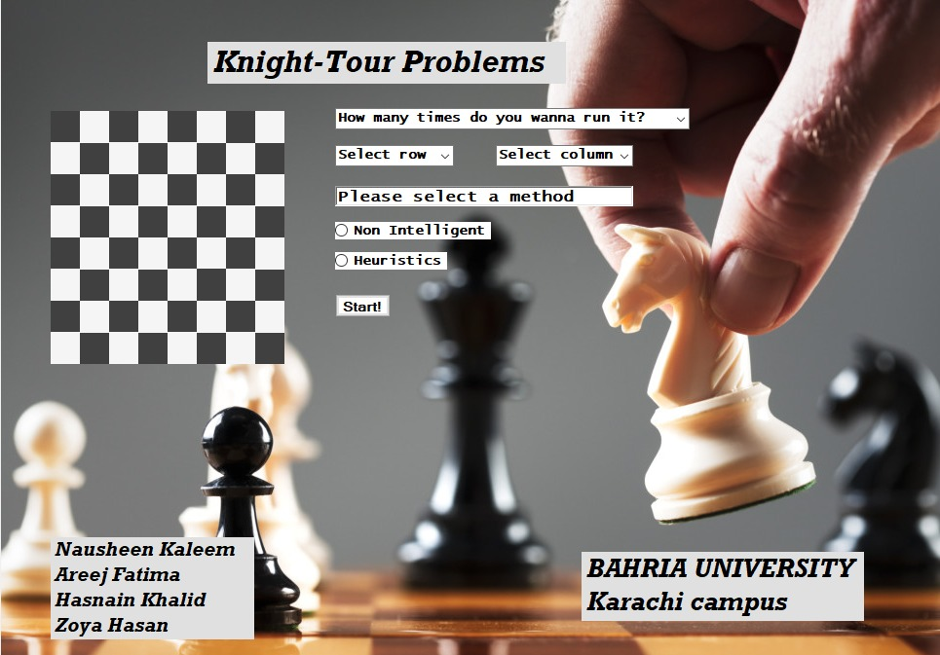

Position And Method Selection:
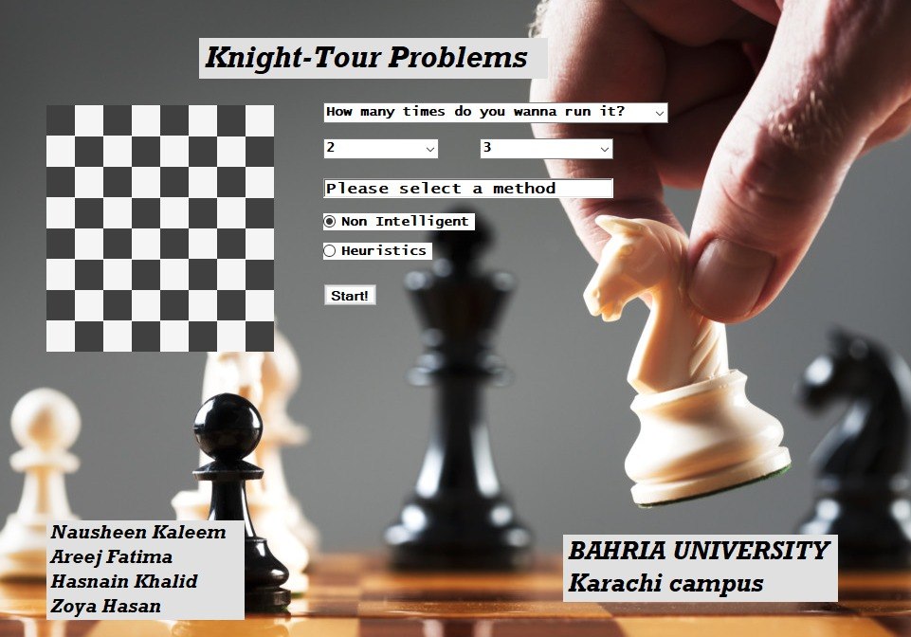

Dialogue box Upon Non-Intelligent Method:
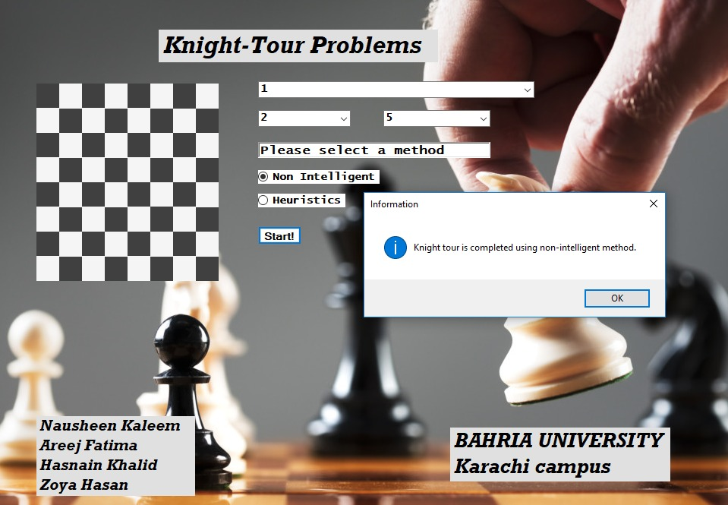

Output for Non-intelligent method:
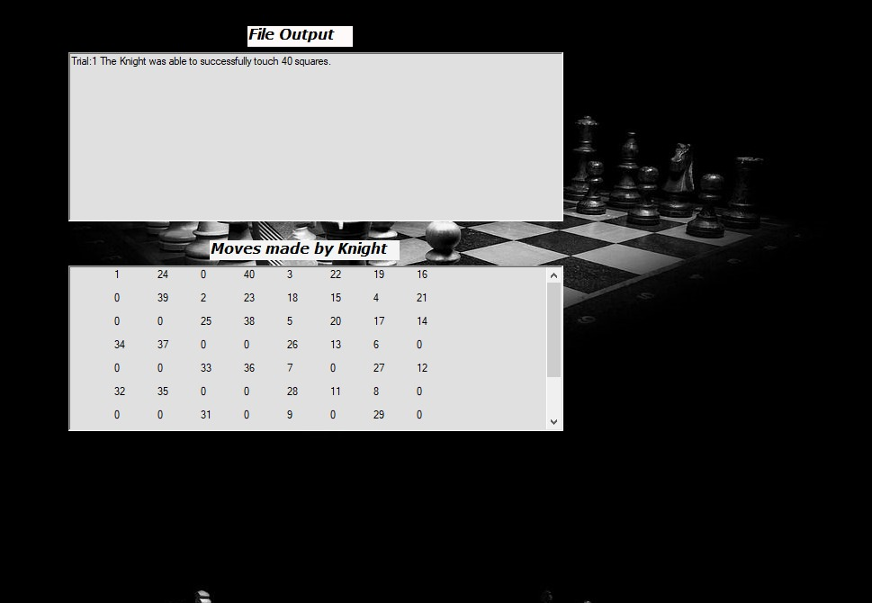

Dialogue box Upon Heuristics Method:
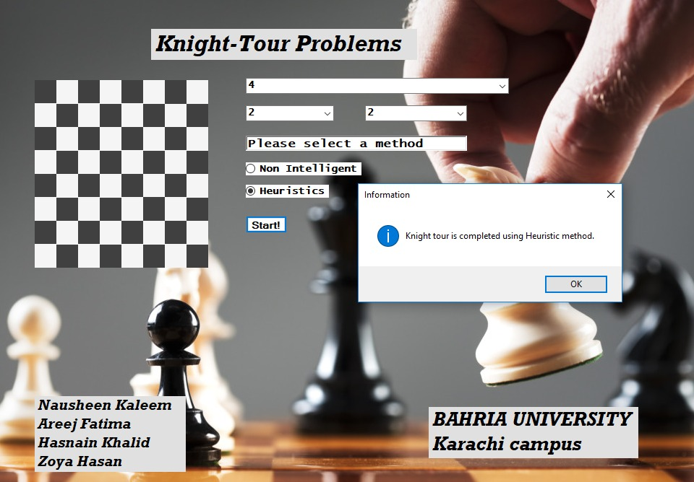

Average Of Squares Visited:
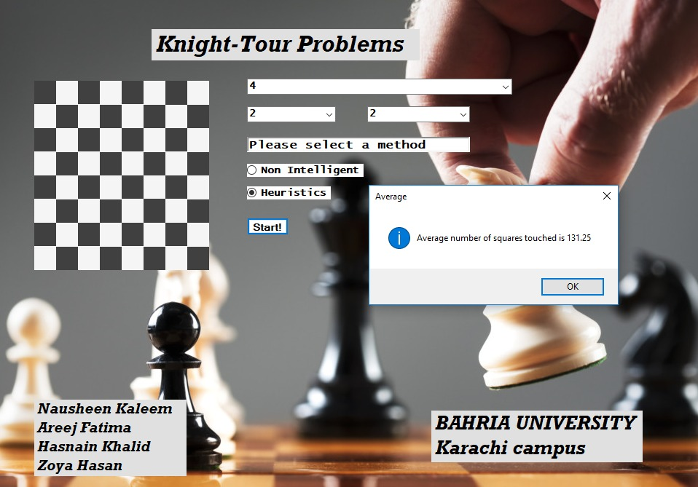

Standard deviation of squares visited:
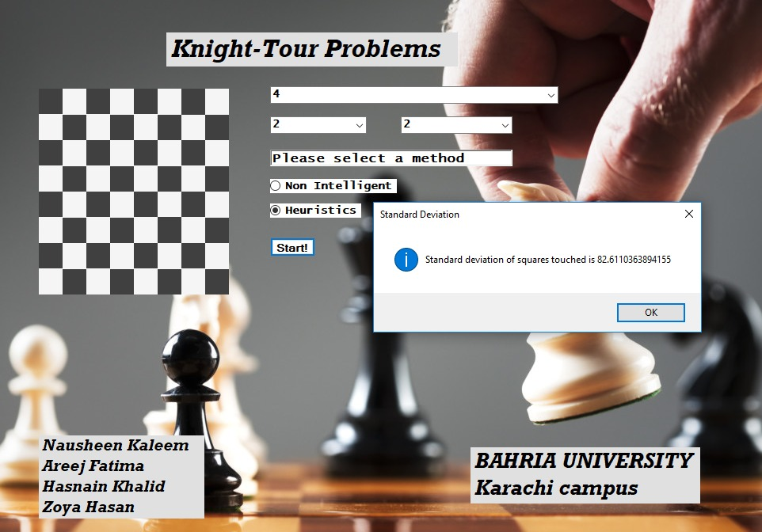

CONCLUSION
The strategy pattern will enable our knight to make move according to suitable algorithm at runtime. This helps the knight to use different algorithms at different instances of the game to move forward and make next move.
It also provides an efficient solution to the knight’s tour problem while using 2D arrays, recursion and some other convenient algorithms. The heuristics method performs better than the non-intelligent because choosing the next move is selective in the case of heuristic but it is random in the case of the other method.. This gives greater chances for heuristics to guide the knight to a complete tour. In summary, general arrangement with heuristics provides a greater guarantee of finding solutions to the Knight’s tour problem than other approaches. In addition, it finds a greater number of solutions and with less time on average the better than all of the other approaches.

REFERNCES

Following are the links we gone through to take guide regarding our project.

- https://www.codesdope.com/course/algorithms-knights-tour-problem/
- https://medium.com/@shubham.singh98/knights-tour-problem-backtracking-65140571ae44
- https://softwareengineering.stackexchange.com/questions/360925/modification-in-knights-tour-problem
- https://dl.acm.org/doi/10.5555/1704840.1705016
- https://www.google.com/search?q=which+architectural+style+can+br+used+in+chess+board+game&ei=UXbbYLfjFumRlwTr_pX4Aw&oq=which+architectural+style+can+br+used+in+chess+board+game&gs_lcp=Cgdnd3Mtd2l6EAM6BwgAEEcQsAM6BAghEApKBAhBGABQuhJY4j9g1ERoBHACeACAAZACiAGbGpIBBjAuMi4xM5gBAKABAaoBB2d3cy13aXrIAQjAAQE&sclient=gws-wiz&ved=0ahUKEwj3z4zRy73xAhXpyIUKHWt_BT8Q4dUDCA4&uact=5
- https://sourcemaking.com/design_patterns/strategy
- https://www.infoworld.com/article/2072189/the-knight-s-tour.html?page=2

THE END

